The Buy-write Strategy, Index Investment AND The Efficient Market Hypothesis:
More Australian Evidence

Darren O’Connell
doconnell@arach.net.au
Barry O’Grady
Barry.O'Grady@cbs.curtin.edu.au

Curtin University of Technology
GPO Box U1987
Perth

Abstract

The purpose of this study is to examine the performance of the buy-write strategy in the context of a benchmark index model. Three portfolios are formed using the Whaley (2002) approach; one for a portfolio of bank bills held to maturity, one for a benchmark index only strategy and the third for a benchmark index portfolio hedged by index call options. The study uses Australian daily data between the period 1991 and 2006 with portfolio performance being judged on mean-variance, mean-semi variance and stochastic dominance measures of risk-adjusted return. The results confirm that the buy-write strategy delivers a superior return to the index-only portfolio with a lower standard deviation of return. On both total risk, systematic risk-adjusted and stochastic dominance basis, the buy-write strategy outperforms the index-only portfolio. In addition, the strategy is seen to produce abnormal returns and therefore provides further evidence that appears to violate the efficient market hypothesis.

Keywords: Buy-write, covered call, index portfolios, total risk, systematic risk-adjusted excess returns, efficient market hypothesis.
Table of Contents

List of Figures iii
List of Abbreviations iv
1. Introduction 1
2. Literature Review 2
2.1 Distributions of Returns for Portfolios Containing Options 2
2.2 Performance of Option Strategies 3
2.3 Option Strategies and the Efficient Market Hypothesis 10
3. Institutional Detail 16
3.1 The Buy-write Strategy 16
3.2 The Trading Environment 18
3.3 Equities and Options Turnover 20
4. Methodology and Data 21
4.1 Construction of the S&P/ASX Buy Write Index 21
4.1.1 The ASX / Jarnecic Methodology 21
4.1.2 Standard & Poor’s Methodology 22
4.2 Portfolio Performance Measures 24
4.3 Stochastic Dominance 26
4.4 Outlier Analysis 28
4.4.1 Grubbs’ Test for Outliers 28
4.4.2 Extent of Outliers 29
4.5 Data 31
5. Results and Performance 32
5.1 Properties of Realised Daily Returns of the XBW 32
5.2 Portfolio Performance Measures 36
5.3 Stochastic Dominance Tests 37
5.4 Outlier Analysis 37
5.5 The Source of Returns 39
5.5 Portfolio Diversification with an Index Buy-write Strategy 40
6. Summary and Conclusions 41
Appendix 1 – Option Contract Specifications used in the XBW 47
Appendix 2 – Regression Analysis 48
2.1 Regression analysis based on standard deviation 48
2.2 Regression analysis based on semi-standard deviation 48
2.2 Regression analysis based on semi-standard deviation 49
2.3 Regression analysis based on standard deviation without outliers 50
2.4 Regression analysis based on semi-standard deviation without outliers 51
Appendix 3 – Transaction Costs 52
3.1 Introduction 52
3.2 Assumptions and Calculations 52
3.3 Conclusion 53
Appendix 4 – Stochastic Dominance 54
Appendix 5 – Efficient Portfolios 56

List of Figures

 |  | Page
Table 1: | Profit / Loss Outcomes of the Buy-write Strategy at Expiry | 16
Chart 1: | Profit / Loss Outcomes of the Buy-write Strategy at Expiry | 16
Chart 2: | Comparison of Long Only and Buy-write Strategy Distributions | 17
Chart 3: | Turnover on ASX (equities) and Volume in ASX Options | 19
Table 2: | Sample of options used in construction of XBW | 23
Table 3: | Summary Statistics for XBW and alternative assets daily since December 31, 1991 | 27
Chart 4: | Distribution of Daily Rates of Returns – 1991 – 2006 | 28
Chart 5: | Buy-write Strategy – Growth of $10,000 initial investment | 29
Chart 6: | Annualised Returns vs. Risk (December 31, 1991 – December 31, 2006) | 30
Chart 7: | Rolling 3-year Annualised Returns & Risk | 30
Table 4: | Risk Adjusted Performance Measures | 31
Table 5: | Results of Grubbs’ Test for Outliers | 32
Table 6: | Extent of Outliers within each Dataset | 32
Table 7: | Summary of Regression Output for Outlier-adjusted Dataset | 33
Table 8: | Sub-sample Regression Models | 33
Chart 8: | Index Call Option Daily Realised Volatility & Quarterly Premiums | 34
Chart 9: | The Mean-Variance Efficient Frontier | 35
Table 9: | ASX 200 Index Options | 42
Table 10: | SFE SPI Options (on Index Futures) | 42
Table 11: | Jensen’s Alpha Regression based on Standard Deviation | 43
Chart 10: | Correlation of Risk-adjusted Returns (Standard Deviation) | 43
Table 12: | Jensen’s Alpha Regression based on Semi-standard Deviation | 44
Chart 11: | Correlation of Downside Risk-adjusted Returns | 44
Table 13: | Jensen’s Alpha Regression based on Standard Deviation without Outliers | 45
Chart 12: | Correlation of Risk-adjusted Returns with Outliers Removed | 45
Table 14: | Jensen’s Alpha Regression based on Semi-standard Deviation without Outliers | 46
Chart 13: | Correlation of DS Risk-adjusted Returns with Outliers Removed | 46
Table 15: | 15: Sample of Typical Fees for Australian Internet Brokers | 48
Table 16: | Portfolio Construction and Associated Charges | 48
Table 17: | Summary of Transaction Costs | 48
Chart 14: | Return Distributions | 49
Chart 15: | First Stochastic Dominance | 49
Chart 16: | Second Stochastic Dominance | 50
Chart 17: | Third Stochastic Dominance | 50
Table 18: | Calculation of the Mean-Variance Efficient Frontier | 52
Chart 18 | The Mean-Variance Efficient Frontier | 52

List of Abbreviations

AEST | Australia Eastern Standard Time
ASX | Australian Securities Exchange
ATV | Average Transaction Value
BAB | Bank Accepted Bills
BXM | CBOE’s Buy-write Monthly Index
CAI | Composite Accumulation Index
CAPM | Capital Asset Pricing Model
CBOE | Chicago Board Options Exchange
CCX | Covered Call Index
CDF | Cumulative Density Function
CIS | Covered Index Strategy
CST | US Central Standard Time
CSP | Closing Settlement Price
EMH | Efficient Market Hypothesis
EUREX | European Derivatives Exchange
FSD | First Stochastic Dominance
G-stat | Grubbs’ Test Statistic
HPR | Holding Period Returns
MV | Mean-Variance
NYSE | New York Stock Exchange
OLS | Ordinary Least Squares
RBA | Reserve Bank of Australia
S&P | Standard and Poors
SD | Stochastic Dominance
SFE | Sydney Futures Exchange
SMI | Swiss Market Index
SPI | Share Price Index
SPX | S&P 500 Index Options
SSD | Second Stochastic Dominance
TSD | Third Stochastic Dominance
UPR | Upside Potential Ratio
XBW | S&P/ASX’s Buy-write index
XJO | All Ordinaries Index
XPI | All Ordinaries Index Options

1. Introduction

In recent years, many investors have turned their attention to investments with higher yields that generate steady income and lower volatility for their portfolios. One strategy that can achieve this is the buy-write strategy in which an investor buys a stock or basket of stocks, and also sells call options that correspond to the stock or basket. This strategy can be used to enhance a portfolio’s risk-adjusted returns and reduce volatility at times when an investor is willing to forgo some upside potential in the event of a bull market in equities.

Initially, the strategy was shunned after a number of academic studies, which were published during the 1970s by scholars such as Merton and Scholes, doubted its value because risk reduction was usually gained at the expense of return (O’Grady and Wozniak 2002, p. 4). As financial markets evolved and option-pricing models became more sophisticated, the covered call strategy was seen to deliver greater benefits. This was particularly the case for portfolio managers who were seeking to stabilise their portfolios without the need to liquidate during the bear markets that followed the 1987 equity market crash. Indeed, the strategy became so popular in the US that it spawned a Chicago Board Options Exchange (CBOE) produced index, which can be used by investors, to benchmark the performance of buy-write option strategies (CBOE, 2002).

Research on the US market provides some confirmation that the implied standard deviation of call options on index futures is greater than “realised volatility” suggesting that index call options are over-priced. This appears to be the most compelling reason why the buy-write and covered call strategies outperform index-only portfolios. Studies conducted in Australia find similar evidence of option mispricing although whether this is due to local portfolio managers competing for insurance or the lack of liquidity is unclear. Regardless, it is likely that the mispricing present in the Australian market allows the local buy-write strategy to outperform the index-only portfolio. This study replicates the Whaley (2002) index model by application to the Australian equities market. It examines the performance of a buy-write strategy, which involves the purchase of an index as a proxy for a portfolio of stocks underlying the benchmark index and simultaneously writing just out of the money index options versus an index only portfolio.

The results discussed here support those established by Whaley (2002) and others that the buy-write index strategy generates not only a higher return than the index-only portfolio but also exhibits a lower variance. On a total risk, systematic risk-adjusted and stochastic dominance basis, the buy-write strategy outperforms the index portfolio. This leads into a discussion on whether the strategy generates an abnormal return and if so would not this constitute a violation of the Efficient Market Hypothesis (EMH)? The rationale behind implementing a buy-write index strategy, (i.e. enhancement of returns or reduction of portfolio risk), violates a number of key assumptions underlying EMH which, as demonstrated by the results, can lead to the identification and exploitation of previously unidentified market and institutional inefficiencies.

The remainder of this paper is structured as follows. The next section reviews the available literature while section 3 describes the institutional detail relevant to the study reported in this paper. This is followed by section 4, which discusses the data and methodology used to examine the profitability of buy-write strategies. Section 5 reports the results and section 6 concludes.

2. Literature Review

2.1 Distributions of Returns for Portfolios Containing Options

The payoff of equities is linear and additive so that the payoff of a portfolio of equities is also linear but the same cannot be said of the payoff on an option contract. Indeed, above its exercise price, the payoff of a call option is linear but below it is horizontal therefore these properties must alter the return distribution of a portfolio of equities that contain options.

Academics and practitioners have extensively documented this transformation; the foremost of which is arguably Bookstaber and Clarke (1984) who use mathematical algorithms to compare the distributions between stocks and combinations of stock / option portfolios. They find that writing call options on a portfolio lead to an asymmetric payoff, in effect, a rightward shift in the entire distribution followed by a truncation of payoffs at a price-determined pivot point. The authors then concentrate on the effects of options on portfolio performance. Since the inclusion of options leads to an asymmetric distribution of returns, traditional performance measures such as the Sharpe or Treynor ratios can lead to biased conclusions.

Traditionally, a strategy of writing calls rather than puts on a portfolio was generally supposed to be more profitable. Bookstaber and Clarke (1985) show that, in reality, the put option portfolio truncates the negative tail of the distribution introducing positive skewness while the call portfolio does the opposite. Therefore, the latter decreases the desirable part of the variance while the former decreases the negative portion. Given the difference in risks of the two strategies, investors cannot expect the risk/return relationship to be the same and a simple, one dimensional measure of risk such as variance will cause erroneous conclusions. Groothaert and Thomas (2003) believe that, as yet, no generally accepted performance measure has been devised to accurately explain these non-linear return distributions.

Benesh and Compton (2000) consider the historical return distributions useful for assessing the risks and potential rewards associated with different financial instruments. They find that options, in particular, are not accurately represented under this framework. Their paper attempts to provide historical return distributions, in a more interpretable format, for calls, puts and covered calls traded on the CBOE from 1986 to 1989. Using simple descriptive statistics, the results show that the covered call strategy, in particular, produces lower mean holding period returns (HPR) than the corresponding underlying stocks. The lower average returns were attributable to the sacrificing of upside potential on a stock beyond the pre-determined exercise price. In other words, the premium received was insufficient to compensate for the opportunity losses on the stocks because of the relatively bullish nature of the market that existed during the period of study. Interestingly, however, the authors find that the covered call strategy does result in lower risk compared to the underlying stocks.

2.2 Performance of Option Strategies

Historically, the available literature on either buy-write or covered call strategies has been thin due to the perception that they delivered little benefit to the investor. This view was reinforced by the seminal work of Merton, Scholes and Gladstein (1978) who studied an equally weighted, fully hedged covered call strategy based on a portfolio of 136 US stocks. This portfolio is rebalanced every six months and option prices are based on the Black-Scholes pricing methodology. They find that the covered call strategy reduces both risk and return, and, more importantly, induces negative skewness that becomes slowly positive as deeper out-of-the-money calls are used. These results imply that the performance of the covered call strategy will improve, relative to a stocks-only portfolio, if higher options prices can be obtained than those provided by the Black-Scholes model. Four years later, Merton, Scholes and Gladstein (1982) investigated the protective put strategy on the same basis. This time though, option prices were provided by Merton’s (1973) early exercise Black-Scholes model, which resulted in reduced portfolio risk and return. Findings indicate that in-the-money puts lower returns and variance more than out-of-the-money puts but as before, mispriced option contracts will produce increased gains for moderate increases in variance.

An interesting attempt to form efficient portfolios was made by Booth, Tehranain and Trennephol (1985) using 3003 portfolios, 1001 for each options / treasury bills, covered calls and stock only strategies, based on randomly determined asset weights. The study was performed on 103 US stocks between July 1963 and December 1978 using 6-monthly calculated theoretical option prices. Portfolio performance is judged on the basis of mean-variance, mean-semivariance, mean-skewness and stochastic dominance approaches. The results show that when drawing an efficient portfolio from 3003 randomly created portfolios, a disproportionate percentage of those were based on option strategies. The authors’ claim that the large proportion of option strategies in the efficient set indicates the importance of option strategies in the maximisation of investor utility.

Stochastic dominance is used by Clarke (1987) to show the relative preference of the covered call and protective put strategy. To study the performance of the two strategies on a portfolio of 20 equally weighted stocks, the study uses the Bookstaber and Clarke (1979) algorithm for simulating return distributions. Clarke (1987) concludes that while both strategies came close to dominating the stock-only portfolio, they fall short of improving the efficiency of the portfolio. However, the author shows that if the Black-Scholes pricing formula produces mis-priced option premiums, then both strategies will dominate the stock only portfolio.

By finding both best possible asset weights and hedge ratios, the study by Morad and Naciri (1990) was the first to actually optimise an options portfolio. The study examines the performance of the covered call strategy on a portfolio of 22 US stocks using actual market data for option prices. The authors adopt a modified Markowitz optimisation algorithm to produce the best possible asset weights and hedge ratios as outputs. By comparing stocks-only and options-hedged efficient frontiers in the mean-variance and stochastic dominance framework, they are able to ascertain the relative superiority of each strategy. Their results show that it is indeed possible to create more mean-variance efficient portfolios by following the covered call strategy. In addition, the results obtained in the ex-post period held in the ex-ante period. An examination of a stocks-only, equally weighted portfolio and a fully covered equally weighted portfolio exhibits no dominance over the covered call strategy. O’Grady and Wozniak (2002, p. 5) speculate that is the reason why some of the previous studies show no benefits to the covered call strategy in terms of a better risk/return relationship.

Lhabitant (1998) examines the problem of performance measurement for non-symmetrical return distributions on data from 1975 to 1996. These are typically the result of option strategies such as the covered call and the protective put. He claims that mean-variance performance measures are inadequate because they do not account for the third and fourth moments of the return distribution (i.e. skewness and kurtosis respectively). Under this framework, covered call writing will mean-variance dominate the stock, which itself will mean-variance dominate the protective put. As a consequence, using measures such as the Sharpe ratio for option strategies actually overstates the performance of the covered call strategy and understate the performance of the protective put strategy. As an alternative, Lhabitant (1998) proposes the use of the first and second-degree stochastic dominance with a risk free asset as a performance measure since this requires few restrictions on investor preferences and no restriction on asset return distribution.

Isakov and Morad (2001) uses the above methodology to study the performance of the covered call strategy in the Swiss share market using real market data on eleven stocks and options prices. Their analysis shows that the covered call strategy produces a more mean-variant efficient set of portfolios than the stock-only strategy. The authors also examine the performance of the covered call strategy when Black-Scholes produced options prices are used but the results did not deliver any superior performance. Authors such as Rubenstein (cited in Isakov & Morad, 2001) find that the Black-Scholes pricing formula underprices option premiums significantly, the underpricing being especially prevalent for out-of-the-money, short-dated call options. This could be yet another reason why previous studies accorded no preference for the covered call strategy.

Of more relevance to this study, O’Grady and Wozniak (2002) examine the performance of an Australian covered call strategy in a portfolio context between 1993 and 2001. The methodology was adapted from the Morard and Naciri (1990) optimisation model and expanded by the use of the Bayes-Stein shrinkage estimation procedure. The results show that hedging a portfolio of stocks using call options allows the investor to attain a portfolio with improved risk/return characteristics. The results are robust to stochastic dominance testing and the dominance of the covered call strategy is still present, although somewhat diminished, when estimation risk is removed. In addition, the authors examine the work of Merton, Scholes and Gladstein (1978) in which an equally weighted fully covered portfolio delivers lower risk at the expense of lower returns. O’Grady and Wozniak (2002, p. 21) doubt the findings of Merton, Scholes and Gladstein (1978) and conclude, along with Morard and Naciri (1990) and Isakov and Morard (2001), that equally weighted fully covered and unhedged portfolios fail to deliver the benefits of the covered call strategy. This is because neither portfolios are members of the efficient set. Unfortunately, this study was hampered by a limited sample size and a relatively short timeframe. The portfolio tested contained just 11 stocks being those that had option contracts listed for the full 8-year study period. Again this is symptomatic of the size and underdevelopment of the Australian market.

In another relevant paper, Leggio and Lien (2002) discuss how, using the mean-variance framework, the covered call investment strategy was seen as an inefficient method of allocating wealth. Referring to their earlier work, Leggio and Lien (2000), the authors question the use of the covered call strategy as a long-term wealth creation strategy, which, at the time, was popular with US financial planners. Leggio and Lien (2000) compare the performance of an index portfolio and a covered-call portfolio with performance being measured by the Sharpe, Sortino and the Upside Potential Ratios (UPR). They find that the index portfolio was the preferred strategy using the UPR because this metric correctly measures risk-adjusted performance, whereas the Sharpe and the Sortino ratios do not. The results of this study calls into question the comparisons of other investment strategies that do not use the upside potential ratio as the performance evaluator. This paper concludes that, although covered calls reduce the riskiness of the portfolio, it is at the expense of lower portfolio returns, and that the mean-variance framework is an inaccurate depiction of investor utility. Leggio and Lien (2002), using loss aversion framework, which includes the application of stochastic dominance, re-examine the covered call investment strategy and find it significantly enhances investor utility relative to an index portfolio investment strategy. They conclude that loss aversion's more accurate depiction of investor preferences and behaviour helps to explain the popularity of the covered call investment strategy.

Aided by the 1988 introduction of the CBOE’s Buy-write Monthly Index (BXM), interest in the strategy grew considerably following the publication of Whaley’s (2002) landmark study. It appears that this work was the first to really subject the index buy-write strategy to a full rigorous analysis over a timeframe that incorporated both phases of the market and spawned a number of related works thereafter. As this research is pivotal to the entire index buy-write industry globally, it is necessary to spend some time reviewing this particular work.

Whaley (2002) examines a strategy involving the purchase of a portfolio underlying the S&P 500 Index and simultaneously writing a just out-of-the money S&P 500 Index call option traded on the CBOE. To understand the construction of the BXM, Whaley (2002) considers the total return nature of the underlying index. In computing the S&P 500, Standard and Poor’s makes the assumption that any cash dividend paid on the index is immediately re-invested in more shares of the index portfolio.

The daily return of the S&P 500 is given as follows:

R_{St} | = | S_{t} – S_{t-1} + D_{t} | (1)
R_{St} | = | S_{t-1} | (1)

S_{t} is the reported S&P 500 index level at the close of day t, and D_{t} is the cash dividend paid on day t. The numerator consists of the gain over the day, which comes in the form of price appreciation, S_{t} – S_{t-1}, and dividend income, D_{t}. The denominator is the investment outlay; that is, the level of the index as of the previous day’s close S_{t-1}. The daily return of the BXM is computed is a similar fashion:

R_{BXMt} | = | S_{t} – S_{t-1} + D_{t} – (C_{t} – C_{t-1}) | (2)
 |  | S_{t-1} – C_{t-1} | (2)

C_{t} is the reported call price at the close of day t. The numerator in this case incorporates the price appreciation and dividend income of the stock index less the price appreciation of the call option, C_{t} – C_{t-1}. The income from holding the BXM portfolio exceeds the S&P 500 portfolio on days when the call price falls, and vice versa. The investment cost in the denominator of the BXM return is the S&P 500 index level less the price of the call option at the close on the previous day.

To generate the history of the BXM returns, Whaley (2002) accounts for the fact that call options were written and settled under two different S&P 500 option settlement regimes. Prior to October 16, 1992, the afternoon settlement S&P 500 calls were the most actively traded, so they were used in construction of the BXM. The newly written call option was to be sold at the prevailing bid price at 3PM (US Central Standard Time), when the settlement price of the S&P 500 index was being determined. The expiring call’s settlement price was:

C_{Settle, t} | = | max(0, S_{Settle, t} – X) | (3)

C represents the settlement value of the call option, S is the settlement price of the underlying index and X is the exercise price of the call option. After October 16, 1992, the morning settlement contracts became the most actively traded and were used in construction of the BXM. The expiring call option was settled at the open on expiration day using the opening S&P 500 settlement price. A new call with an exercise price just above the S&P 500 index level was written at the prevailing bid price at 10AM (CST).
Other than when the call option was written or settled, daily BXM returns are based on the midpoint of the last pair of bid-ask quotes appearing before or at 3PM (CST) each day:

C_{3PM, t} | = | Bid price_{3PM} + ask price_{3PM} | (4)
C_{3PM, t} | = | 2 | (4)

After October 16, 1992, the daily return is computed using the following formula:

R_{BXM, t} | = | (1 + R_{ON, t})(1 + R_{ID, t}) - 1 | (5)

R_{ON, t} is the overnight return of the buy-write strategy based on the expiring option, and R_{ID, t} is the intra-day buy-write return based on the newly written call option.

The overnight return is calculated as:

R_{ON, t} | = | S_{10AM, t} + D_{t} – S_{close, t} – (C_{settle, t} – C_{close, t-1}) | (6)
R_{ON, t} | = | S_{close, t} – C_{close, t-1} | (6)

S_{10AM, t} is the reported level of the S&P 500 index at 10AM on the expiration day, and C_{Settle, t} is the settlement price of the expiring option. The intra-day return is defined as:

R_{ID, t} | = | S_{close, t} – S_{10AM, t} – (C_{close, t} – C_{10AM, t}) | (7)
R_{ID, t} | = | S_{10AM, t} – C_{10AM, t} | (7)

These call prices are for newly written options.

Whaley (2002) demonstrates that such a passive buy-write strategy, on average, generated positive risk-adjusted returns over the period June 1988 to December 2001, both before and after controlling for the cost of trading the option. He finds that the index portfolio produced a mean monthly return of 1.172 per cent with a standard deviation of 4.103 per cent. In contrast, the CBOE buy-write index (the S&P 500 Index fully covered with call options) returned 2.340 per cent with a standard deviation 2.663 per cent. In other words, the buy-write index produced a superior monthly return compared to the S&P500 Index, but at less than 65 per cent of the risk level. Furthermore, by matching the risk level of the buy-write index to the S&P 500 Index, the former returned 0.322 per cent more than the latter.

Similarly, Hill and Gregory (2003) consider the performance of covered calls using S&P 500 index options over the period 1990 – 2002. Several key insights are drawn from this in-depth analysis of the covered index strategy (CIS) returns. They find that this lower risk-profile strategy (beta of 0.70 – 0.80) compares favourably in returns with equivalent-risk strategies combining equities and bonds. Depending on the benchmark used, the average alpha over the 13-year period ranged between 120 and 400 basis points. The regular option premium generated in covered writing strategies provides a high regular cash-flow component comparable to the characteristics of a high dividend yield portfolio. The equity (beta) exposure desired could be achieved by selecting a specific out-of-the-money strike price. This is akin to controlling risk by either shifting between stock and cash-equivalents or by targeting tracking error in an active equity strategy. The tracking error characteristics of a CIS to the S&P 500, or any other risk-adjusted benchmark, are in the range of other enhanced index type strategies, i.e. 1 to 4 per cent. Overall, Hill and Gregory (2003) conclude that such a strategy could outperform the index but was best suited to periods of moderate or negative equity returns.

Groothaert and Thomas (2003) undertake a theoretical experiment on the main Swiss stock exchange. They construct a hypothetical buy-write index fashioned in the Whaley mould. To achieve this, the authors use the benchmark Swiss Market Index (SMI), and its constituents’ call options traded on EUREX as the foundation. Consequently, they produce a theoretical buy-write index (CCX) from which they assess its return distribution and resulting performance. Groothaert and Thomas (2003) find that whilst the SMI and the composite buy-write indices produce negative returns over the time horizon, the CCX gave the investor a markedly smaller loss (-2.27 percent versus -7.75 percent). In addition, the CCX produced a standard deviation of 17.91 per cent versus 25.39 percent and all other risk measures (e.g. Sharpe and Traynor ratios measured for total risk and downside risk) exhibited a similar trend, further proof of the buy-write strategy’s ability to deliver enhanced returns for reduced risk. An interesting aside that mirrors this Australian study was the authors’ observation on the lack of liquidity in the Swiss exchange traded option market, forcing EUREX, to post theoretical option prices, which are considered overpriced. Unfortunately, this study was hampered by a number of factors including limited availability of options on all SMI constituent stocks and a relatively short timeframe.

Feldman and Roy (2004), on the other hand, published a case study on the BXM Index and the initial performance of the first money manager licensed to run strategies linked to the buy-write index. The study finds that over the 16-year period studied, the buy-write index had the best risk-adjusted performance of the major domestic and international equity-based indices examined. Indeed, based on historical data, when a 15 per cent allocation of the buy-write index is added to a moderate portfolio, volatility is reduced by almost a full percentage point with almost no sacrifice of return. Furthermore, the risk-adjusted return for the buy-write strategy (as measured by the skew-adjusted Stutzer Index) was 38 per cent higher than that of the S&P 500. The Feldman and Roy (2004) study notes that the Sharpe Ratios were 0.75 for the BXM Index and 0.53 for the S&P 500, but the study emphasises the use of the skew-adjusted Stutzer Index because of the negative skews for both the BXM (-1.25) and S&P 500 (-0.46) indices.
Using Whaley’s (2002) principles, the first Australian index buy-write study was undertaken by Jarnecic (2004). The author analyses the risk and return associated with the purchase of an equities portfolio based on the S&P/ASX 200 index and writing out-of-the-money index call options over the period 1987 to 2002. The buy-write strategy produced an excess return, relative to the index-only strategy of 0.56 per cent for a standard deviation of 5.78 per cent versus 6.15 per cent, which were considered stronger than Whaley’s (2002) results. This work was based on quarterly data that yielded a mere 60 data points and suffers from too brief an analysis on which to fully understand the index buy-write strategy’s effectiveness in Australia’s investment landscape.

El Hassan, Hall and Kobarg (2004) undertake a study analysing the risk-return characteristics of the covered call strategy over Australian equities held as part of a balanced multi-asset portfolio. Specifically, the study, covering the period July 1997 to June 2004, analyses the performance of a balanced portfolio where funds are invested across various asset classes. These included Australian equities (40 per cent), international equities (25 per cent), fixed income (20 per cent), property (10 per cent) and cash (5 per cent). The covered call strategy, following Whaley’s (2002) BXM principles closely, was implemented by selling slightly out-of-the-money call options on the Australian equities, component representing the top 20 stocks by market capitalisation and liquidity. Options were selected to be 5 – 15 per cent out-of-the-money with maturities of three months, as per the Australian market convention and the portfolio was rebalanced at the option expiry rollover date. The results shows that covered call strategies have the effect of enhancing the average return of the portfolio, reducing the standard deviation of returns and improving the risk-adjusted returns, as measured by the Sortino and Sharpe ratios. As expected, the covered call strategies also have the effect of reducing the range of the returns observed for the portfolio. Interestingly, the Sortino ratio was chosen specifically to assess performance of the strategy in terms of excess return per unit of downside risk.

Following on from both Whaley (2002) and Feldman and Roy (2004), Callan and Associates (2006) extend the BXM study by looking at a much longer history. They undertake a far more detailed analysis and look at the applicability of this strategy as both a diversified portfolio enhancer (by substituting the BXM for a portion of the large cap equity allocation) and a standalone packaged investment product. The results show that the BXM generated a return comparable to the S&P 500 but at two-thirds of the risk and a superior risk-adjusted return (as measured by monthly Stutzer index and Sharpe ratio). These results are in line with Whaley’s (2002) observations. The study also notes that the BXM generates a return pattern different from the S&P 500 that offers a source of potential diversification due to lack of direct correlation (0.87). The addition of the BXM to a diversified investor portfolio would have generated significant improvement in risk-adjusted performance over the past 18 years.

2.3 Option Strategies and the Efficient Market Hypothesis

In an efficiently functioning securities market, the risk-adjusted return of a buy-write strategy (or any other option-based strategy for that matter) should be no different from the underlying market portfolio. Recent years have seen a reinvestigation of the EMH of financial market performance. A hypothesis that once had widespread acceptance, the EMH has not fared so well under newer tests.

Galai (1978) tests (1) whether the prices of stocks on the NYSE and the prices of their respective call options on the Chicago Board Options Exchange behave as a single synchronised market, and (2) whether profits could have been made through a trading rule on call options on the CBOE and their respective stocks on the NYSE. He found that the two markets do not behave as a single synchronised market and that positive profits (ignoring risk differentials) could have been made from the trading rule (which was based on violations of the lower boundary condition of the option price). However the average profits are small relative to the dispersion of outcomes, and it appears that most of this would be wiped out by transaction costs for non-members of the exchange. Galai (1978) therefore implied that one or both securities markets were inefficient.

Similarly, Chiras and Manaster (1978) use option prices generated by the Black-Scholes model and actual option prices to calculate implied variances of future stock returns. These variances prove to be better predictors of future stock return variances than those obtained from historical stock price data. In addition, a trading strategy that utilises the information content of implied variances yield abnormally higher returns that appear to be large enough to profit net of transaction costs. The authors conclude that in the period covered by their data, June 1973 to April 1975, the prices of CBOE options provided the opportunity to earn economic profits and, therefore, that the CBOE market was inefficient.

In support of EMH, Johnson (1986) compares the foreign-exchange rate implicit volatility of call options and put options written on foreign currencies. These implicit volatilities should be equal, and equal to the volatility of the proportional change in the exchange rate, given that option prices are efficient and that the foreign-currency option-pricing model described by Biger and Hull cited in Johnson (1986) holds. The foreign-currency options that are examined in this study are the British pound, Canadian dollar, Japanese yen, Swiss franc, and West German mark. The results of this study support the notions of market efficiency and put-call parity, at least in the global currency market at that time.

Fortune (1996) studies EMH in the context of the market for options on common stocks. The ability of the Black-Scholes model to explain observed premiums on S&P 500 stock index options is subjected to a number of tests. Using almost 500,000 transactions on the SPX stock index option traded on the CBOE in the years 1992 to 1994, the study finds a number of violations of the Black-Scholes model's predictions or assumptions and is therefore inconsistent with EMH.

For the first test, the Black-Scholes model assumes that the market forms efficient estimates of the volatility of the return on the S&P 500. These estimates then become embedded in the premiums paid for options and can be recovered as the option’s “implied volatility”. For the SPX contracts, implied volatility is an upwardly biased estimate of the observed volatility and the former does not contain all the relevant information available at the time the option is traded. This represents a violation of the assumption of forecast efficiency. The test indicates that implied volatility is a poor estimate of true volatility.

Fortune’s (1996) second test is based on the Black-Scholes model’s prediction that options alike in all respects apart from the strike price, should exhibit no relationship between the implied volatility and the strike price. Nor should there be any correlation between implied volatility and the amount by which the option is in or out of the money. This study finds, as have other studies, a “smile” in implied volatility: Near-the-money options tend to have lower implied volatilities than moderately out-of-the-money or in-the-money options.

A third test is derived from the Black-Scholes model’s prediction that put-call parity will ensure that puts and calls identical in all respects (expiration date, strike price, expiration date) have the same implied volatilities. The study finds that puts tend to have a higher implied volatility than equivalent calls, indicating that they are overpriced relative to call options. The overpricing is not random but systematic, suggesting that unexploited opportunities for arbitrage profits might exist. A fourth test is based on measures of the pricing errors associated with the Black-Scholes model. Deviations between the theoretical and observed option premiums should be small and random. Instead the study finds systematic and sizable errors. For the entire sample, calls have pricing errors averaging 10 to 100 per cent of the observed call premium. Puts appear to be more accurately priced, with errors 15 to 40 per cent of the observed premium.

Concluding, Fortune (1996) suggests that in most cases, arbitrageurs take advantage of put overpricing by short selling stock and correct put underpricing by going long. The relative overpricing of puts, therefore, might be the result of inhibitions on the arbitrage required to correct put overpricing. These inhibitions, or rather limitations, in the form of transaction costs and risk exposure, are far greater for the short selling of stock.

Guillaume et al (1995) present a number of stylized facts from a study concerning the spot intra-daily foreign exchange markets. The study first describes intra-daily data and proposes a set of definitions for the variables of interest. Empirical regularities of the foreign exchange intra-daily data are then grouped under three major topics: the distribution of price changes, the process of price formation and the heterogeneous structure of the market. The stylized facts surveyed in this paper shed new light on the market structure that appears composed of heterogeneous agents, rather than EMH assumed homogenous. It also poses several challenges such as the definition of price and of the time-scale, the concepts of risk and efficiency, the modelling of the markets and the learning process.

In analysing one of the critical assumptions of EMH, namely that investors are homogenous in their beliefs, Brock and Hommes (1998) investigate the performance of a number of structural asset pricing models. Citing an earlier empirical work, the authors’ show that simple technical trading strategies applied to the Dow Jones index might outperform several popular EMH stochastic finance models such as the random walk. This result led them to believe that the market contains two typical investor types. The first is described as a rational ‘smart money’ trader who believes that asset prices are determined solely by EMH fundamental value, as given by the present discounted value of future dividends. The second is known as a ‘chartists’ or technical analyst, who believes that the price discounts all known information and trends evident on price charts repeat over time. If there are two types of investors who differ in their beliefs, then the assumption of homogeneity is violated. Heterogenous beliefs about asset price dynamics coupled with a ‘high intensity’ of investment choices causes volatile oscillations around an unstable EMH fundamental that can lead to abnormal returns.

Whilst demonstrating the use of the binomial model in pricing options, Rendleman (1999) voices concern that the principle of risk and return as it applies to options is not well understood by the wider investment community. Specifically, he believes that covered call writing is considered a “return booster” rather than, perhaps, a risk reduction strategy. This view is perpetuated by the notion that proceeds from option writing enhances the return from holding stock. This argument ignores the risk-reducing aspect of covered call writing, which, he says, must reduce the overall strategy’s return when compared to holding un-hedged stock. Rendleman (1999) believes that a correct understanding of this point is essential, as this will radically alter investors’ perception about the true return prospects of common option-based strategies. In essence, when viewed in a risk / return context, there ought not to be an investment strategy involving options (such as a buy-write strategy) that decrease risk whilst simultaneously increasing return. Rendleman (1999) asserts that efficient markets simply do will allow this to occur, as there is no such thing as “a free lunch” in the stock, bond, option or any market for that matter since pricing is considered proficient.

Whaley (2002) demonstrates that the BXM achieved an abnormally higher return over the period June 1988 through December 2000. Stux and Fanelli, and Schneeweis and Spurgin, cited in Whaley (2002), suggests that the volatilities implied by S&P 500 option prices are high relative to realised volatility. Bollen and Whaley (2004) argue that there is excess buying pressure on S&P 500 index puts by active investment managers frequently using exchange-traded options as a risk reduction tool. Since there are no natural counterparties to these trades, market makers must step in to absorb the imbalance. As their inventories grow, implied volatility will rise relative to actual return volatility. The difference is the market maker’s compensation for hedging costs and/or exposure to volatility risk. The implied volatilities of the corresponding calls also rise from the reverse conversion arbitrage supporting the put-call parity theorem.

Consistent with this proposition, Whaley (2002) demonstrates that the implied volatility of index calls is greater than historic realised volatility, although the difference was not constant over time suggesting variation in the demand for portfolio insurance. The difference was persistently positive, averaging 234 basis points over the evaluation period. To prove that the high level of implied volatility was at least partially responsible for the abnormal returns generated by the BXM, the index was reconstructed using theoretical option values derived from the Black-Scholes-Merton (1973) model rather than historical market prices. Again the BXM outperformed the S&P 500 index portfolio but only marginally, particularly so when the theoretically superior semi-variance measure is adopted. This finding, together with that of Fortune (1996) basically confirms Merton, Scholes and Gladstein’s (1978) conjecture that an improved buy-write performance would result if higher option prices could be obtained than those suggested by static models, such as Black-Scholes.

Whaley (2002) concludes that at least some of the BXM’s risk adjusted performance was due to this mispricing of options caused by portfolio insurance demands, and hence any strategies seeking to exploit this anomaly should prove profitable.

Following on from this research, Bondarenko (2003) studies the finding that historical prices for S&P 500 put options were high, and incompatible with widely used asset–pricing models such as the capital asset pricing model (CAPM), the Black-Scholes (1973) model and the Rubenstien (1976) model. The economic impact of such a phenomenon is thought to be large and simple trading strategies that involved selling at-the-money and out-of-the-money puts would have earned extraordinary trading profits, which seemingly violate EMH. In this paper, Bondarenko (2003) implements a novel “model-free” methodology to test the rationality of asset pricing. The main advantage appears to be the lack of required parametric assumptions about the pricing ‘kernel’ or investors’ preferences. In addition, the methodology can be applied when the sample is affected by external shocks such as the Peso Problem and also when investors’ beliefs are incorrect. The methodology adopted is based on a new rationality restriction whereby security prices deflated by risk neutral density must follow a martingale when evaluated at the eventual outcome. The author finds that no model selected from a broad class of models can explain the put pricing anomaly even when allowing for shocks or incorrect investor beliefs. In light of this evidence, the author believes that either new path dependant models are required or that the some of the assumptions underlying the EMH will have to be re-evaluated. Specifically for the latter suggestion, future studies may have to entertain the possibility that investors are not fully rational and that they commit cognitive errors (particularly for strong-form EMH), and question other standard theoretical assumptions such as the absence of market frictions.

Rebonato (2004) examines derivative markets in general, and discusses how deviations from ‘fundamental’ pricing caused by an informationally inefficient assessment of the price of a certain assets affect the validity of EMH. According to market efficiency theory, discounting expected future payoffs using an appropriate discount factor derives the derivative price. The release of new information (a change in fundamentals) can lead an informed investor to reassess the current price for a derivative (that is, a new expectation is produced by the new information), but supply and demand pressures alone cannot. If the fundamentals have not changed, a demand-driven increase in the price of a substitutable security will immediately entice arbitrageurs to short the “irrationally expensive” security and bring it back in line with fundamentals. The more two securities (or bundles of securities) are similar, the less undiversifiable risk will remain, and the more the arbitrageurs will conduct ‘correcting’ trades. The challenge to EHM, states Rebaonato (2004), is there are at least some investors who arrive at decisions that are not informationally efficient and mechanisms that allow better-informed investors to exploit and eliminate the results of these ‘irrationalities’ are not always effective. The prime mechanism to enforce efficiency is the ability to carry out arbitrage. A line of critique to EMH has been developed which shows that arbitrage can be, in reality, risky and therefore the pricing results of irrational decisions made on the basis of psychological features might persist over the long term. The origin of these pricing inefficiencies was always assumed to lie within the psychological domain of investors but may now be institutional particularly if the price of a derivative is disconnected from fundamentals for any reason. Therefore, EMH is regularly violated in derivative markets, leading to profit opportunities, not solely because of irrationality of investors but because arbitrage is unable, at times to correct any imbalances.

Czerwonko and Perrakis (2006) examine the stochastic dominance efficiency in the presence of transaction costs for S&P 500 index futures call and put options. This was done by estimating bounds on reservation write and reservation purchase prices, and then verifying whether the observed option prices satisfied the estimated bounds. Data on past realisations of the underlying asset and under various modelling assumptions about the investor-assumed distribution were used to estimate the bounds. They are then compared to observed market prices and several violations are identified under all distributional assumptions, although these violations were relatively few under forward-looking distributions. The paper then derives trading strategies that exploited these violations and increased expected utility function for any risk-averse investor. The empirical tests undertaken in this study appear to question the weak-form version of EMH in that investors should not be able to profit from trading strategies based on historical data. Yet the authors go onto develop a metric that evaluates the increase in expected utility for any given investor within a certain utility class. This is then linked to the traditional second degree stochastic dominance criterion. Finally, the paper demonstrates, by out-of-sample tests with actual underlying asset prices, that these strategies to exploit the mis-pricing of index futures options do indeed improve risk-adjusted returns for risk-averse investors.

A further assumption of EMH is that perfect competition exists, whereby investors regardless of size can transact without affecting prices. Darden Capital Management (2006, p. 7), in a study on the abnormal returns on stocks promoted to the S&P 500 Index, find evidence that fund managers tend to divide up large orders and accumulate or divest shares during the period between the announcement and inclusion dates. At the very end of trading on the day of inclusion, some index managers engaged in rapid, large trades. This pushes up share prices to close higher than the required S&P 500 inclusion price, compared to the average price at which shares were accumulated during the period directly before these transactions.
In summary, this literature review has shown that most early work tended to discount the benefits of a buy-write strategy since a reduction in risk was obtained at the expense of return. As option pricing models developed, later work began to recognise the fact that options are frequently overpriced relative to fundamental value and this led to a re-examining of the buy-write strategy. Led by Whaley (2002), recent results show that reduced risk need not be accompanied by a reduction in return. Following the lead by the CBOE, the ASX introduced an index buy-write strategy in 2004 and it is the purpose of this study to investigate its properties in the mean-variance and stochastic dominance frameworks, and its implications for EMH.

3. Institutional Detail

3.1 The Buy-write Strategy

A buy-write strategy is an options investment approach whereby an investor buys a portfolio of stocks that are benchmarked to an index, and then simultaneously sells a call option over that index. A buy-write strategy can also be used on individual stocks, by buying the stock and then writing a call option over that stock. If the portfolio or individual shares are already held from a previous purchase, the strategy is commonly referred to as covered call writing. Buy-write is the most basic and widely used options investment strategy, combining the flexibility of listed options with underlying equity ownership (ASX 2006, p. 1). According to the Australian Securities Exchange (2004), the buy-write strategy possesses two important benefits:

  - Selling the call option generates an option premium with profits coming from the receipt of the premium and the time decay of the option (Radoll, 2001). The income from the premium cushions the portfolio from some downside risk. In return for receiving the premium, the option seller gives up some upside gain at a pre-determined level. The cap level on the upside is equal to the strike price of the option;

  - Selling the call option reduces the volatility of returns, as generally speaking the implied volatility of the option when traded is greater than volatility actually realised.

By placing a cap on upside profit potential, the buy-write strategy, by implication, will under-perform in strongly bullish markets and so is, therefore, most effective in trendless markets where volatility is, in general, falling over the strategy time horizon. Conversely, this strategy is expected to outperform in flat and bear markets. Active fund managers use buy-write strategies either on individual stocks or index portfolios in order to boost returns when the market outlook is neutral, or is expected to range around the current level over the quarter. Because exchange traded options offer a wide variety of strike prices, the call options can be written ‘at-the-money’ or slightly ‘out-of-the-money’ depending on the fund manager’s individual viewpoint.

To illustrate the risk / return characteristics of the buy-write strategy consider the following example. Assume today that the level of the S&P/ASX 200 Index is 5500 and a fund manager who controls an equity portfolio closely aligned to the index expects a trendless market for the next three months. To help boost returns (extra alpha) the manager can sell an index call option just-out-of-the-money at 5550 thus receiving a premium of, say, 75 points. Table 1 shows how the portfolio and option values change over a range of index prices.

As per Chart 1, the combination of being long the index and short an index call option generates an entirely new set of payoffs that resemble a synthetic short put position. As the market becomes more bullish, the upside potential is capped at 125 points, denoted by the solid line, thus the fund manager forgoes any additional capital gain. However, the buy-write position outperforms the long only strategy at every point to the left of the intercept between the buy-write and long-only lines (5650).

Table 1: Profit / Loss Outcomes of the Buy-Write Strategy at Expiry

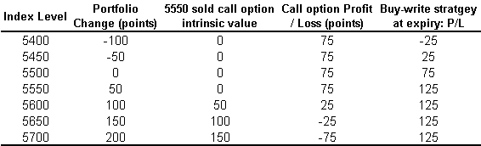
Chart 1: Profit / Loss Outcomes of the Buy-write Strategy at Expiry
There are three possible outcomes at the expiry of the option: the market will advance strongly, will trend within a range or will fall. If the fund manager had called the market incorrectly and prices began to advance strongly so much so that the index was in excess of the option’s strike price of 5550 then the option would be exercised upon the maturity date. The fund manager would be required to cash settle the difference between the final closing level of the index on the maturity day and the options strike price less the option premium retained multiplied by the contract multiplier (i.e. AUD$10) per point. Tergesen (2001) believes that this strategy is most profitable when the portfolio is called and the constituent stocks are transferred the to the option buyer.

If the market did indeed remain trendless, hovering around a value of say 5550, then the call expires without being exercised and the value of the portfolio has increased in value by 125 index points. An unhedged equivalent portfolio would be valued at 50 index points only at the end of the three-month period. Otherwise, if the market fell below 5425, the losses accruing on the portfolio would eliminate the option premium received (Radoll, 2001) but its value would be 75 index points higher than its unhedged equivalent thus downside risk is limited to a degree.

Distributionally, the return of the buy-write strategy is shifted to the right and truncated at the strike price of the sold option while the long only position displays the standard bell shaped curve.
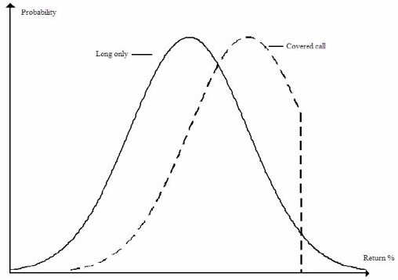
Chart 2: Comparison of Long Only and Buy-write Strategy Distributions
Source: Groothaert and Thomas, (2003)

3.2 The Trading Environment

The All Ordinaries Index (AOI) was the main benchmark for equities trading on the ASX and covered approximately 300 of the largest stocks. On 31 March 2000, a new family of indices was introduced jointly by S&P and ASX, and the main institutional benchmarks became the S&P/ASX200 and S&P/ASX300 indices. The former serves the dual purpose of benchmark and investable index by addressing the need of fund managers to benchmark against a portfolio characterised by sufficient size and liquidity. With approximately 78 per cent coverage of the Australian equities market, the S&P/ASX200 is considered an ideal proxy for the total market (Standard & Poor’s 2006, p. 1). In addition, this index forms the basis for the ASX200 Mini, which is an investable, leveraged, and cash-delivered futures contract that allows investors exposure to the movements of the top 200 stocks and is akin to holding a well-diversified portfolio of stocks, on margin, without the full outlay of capital.

Index Options on the S&P/ASX200 were first listed on the Australian Stock Exchange during March 2000. The expiry day of the call option is the third Friday of the contract month, providing this is a trading day, trading ceases the day prior otherwise. These options are European in exercise and cash settled using the opening price index calculation on the expiry day.

The S&P/ASX 200 Buy Write Index (XBW) is a passive total return index. The underlying index is the S&P/ASX200 Index over which an S&P/ASX200 Index call option is sold each quarter. The back history for the XBW recognises that the index options available to Australian investors have been written over different underlying indices during the period under consideration:

- From December 31, 1991 to April 3, 2000, index options over the SPI futures contract were used. The underlying index for the SPI futures was the All Ordinaries index, as calculated by the ASX;

- From April 3, 2000 to March 31, 2001 index options used were transitional ASX All Ordinaries Index (XPI) options. The S&P/ASX 200 Index (XJO) was introduced on 3rd April 2000 as a replacement benchmark for the Australian market. However a continuation of the former All Ordinaries Index was calculated and disseminated by the ASX to allow for the maturity of the remaining SPI futures contracts. During this period ASX listed index options on the XPI;

- From March 31 2001, S&P/ASX 200 Index options have been used.

The XBW combines the underlying accumulation index (S&P/ASX 200) with an ASX call option selected from the series closest to the money with the nearest expiry. In Australia, index option series expire each quarter, so at the time of selection, each option used in the index will have 3 months to expiry. Once an option series has been selected, it is held to maturity. A new series is selected at the expiry of the current one based on the criteria:

- On the nearest out of the money strike;

- Nearest available expiry.

Since ASX Index options are European style options with cash settlement at expiry, an adjustment to the XBW is made each expiry to reflect the funds, if any that need to be paid to settle the option contract. At the same time, a new option series is written with the proceeds from the option premium being reinvested in the index plus option portfolio in accordance with the formula provided by Whaley (2002).

This differs from the CBOE methodology where index options expire monthly and options with one month to expiry are selected. Otherwise the methodology used in the calculation of the back history mirrors the methodology set out by Whaley (2002) and used by CBOE.

3.3 Equities and Options Turnover

Turnover of ASX equities, together with the volume of options traded are depicted in the Chart 3. Since the introduction of index options in 1983, turnover in ASX equities has increased from $10.3 billion to $1,107 billion by the end of 2006. At the same time, trading in equity options including index options has increased strongly to 22.3 million contracts traded in 2006.

Chart 3: Turnover on ASX (equities) and Volume in ASX Options

Source: Data supplied by ASX

Notice how option volumes increased markedly in the years subsequent to the 1987 global stock market crash before stagnating for most of the 1990s. Following the 2000 dotcom crash and resulting recession, option turnover again began to increase rapidly closely shadowing equities turnover through the resulting bull market.

4. Methodology and Data

4.1 Construction of the S&P/ASX Buy Write Index

From the available literature, it appears that the initial impetus for the development of an Australian buy-write index can be attributed to the success of its CBOE counterpart as well as the increasing popularity of the strategy at the individual stock level . In May 2004, the ASX (refer Jarnecic, 2004) adopted the methodology used by Whaley and launched the S&P/ASX XBW Index and developed a set of historical data adjusted for all the institutional changes described presently. Responsibility for the ongoing maintenance and calculation of the XBW index was given to Standard & Poor’s. They subsequently refined the Whaley (2002) approach and this adds an extra level of rigour and more accurately mirrors the current institutional environment. The historical evolution of the XBW’s methodology is described below.

4.1.1 The ASX / Jarnecic Methodology

In constructing the return on the buy-write strategy, Jarnecic (2004) followed Whaley (2002) very closely, whilst accounting for the peculiarities of the Australian market. The return on the buy-write strategy was calculated assuming the index portfolio is purchased and a just-out-of-the-money index call option was written each quarter and held to expiry. The following expression was used to calculate the quarterly returns on the buy-write strategy:

R_{t} | = | AI_{t} – AI_{t-1} – (C_{t} – C_{t-1}) | (8)
R_{t} | = | AI_{t-1} – C_{t-1} | (8)

AI_{t} is the level of the accumulation index of day t and C_{t} is the price of a just out-of-the-money index call option on day t. The return on the buy-write strategy is compared to the return on the Accumulation Index-only portfolio, as well as the return on a strategy involving the purchase of a 90-day bank bill, which is held to expiration.

To generate the history of the XBW returns, the methodology adopted had to recognise the changes to Australian indices that occurred during 2000 and 2001. Any resulting history for the XBW prior to 2004 is by necessity a composite measure. Jarnecic (2004) obtained index data from Standard & Poor’s and used Share Price Index (SPI) options listed on the SFE as a proxy for S&P/ASX200 options prior to March 2000 (this information being made available through SFE website). XJO option data (exercise prices and option premiums) was obtained from the Australian Financial Review with expiration dates provided by the ASX. Specifically, for each quarterly expiration date, Jarnecic (2004) constructed a hybrid buy-write history using the following data specifics:

- For index options up until March 2000, the exercise and closing prices for just out-of-the-money, nearest to maturity SPI option contracts were used, after which values for the S&P/ASX200 option contracts were used;

- The settlement price of the expiring option contract (SPI or XJO option) is based on the closing value of the relevant stock index that day, and;

- The closing value of the All Ordinaries Accumulation Index up until March 2000, after which closing values of the S&P/ASX200 Accumulation Index were extracted.

Bank bill rates were also used in this analysis, and these were sourced from the Reserve Bank of Australia’s (RBA) website.

4.1.2 Standard & Poor’s Methodology

Standard & Poor’s Custom Index Solutions assumed calculation of the S&P/ASX Buy Write Index from May 2004 onwards. The calculation methodology was adjusted slightly to better reflect the total return nature of a passive buy-write strategy whereby dividends in the underlying index are re-invested in the index on the ex-date. However, the two methodologies are fundamentally the same as the following discussion on the algorithm used by Standard & Poor’s in calculating the XBW will demonstrate.

XBW_{t} | = | XJO_{t} – Callvalue_{t} + Dividend_{t} + Rolloveradjustment_{t} | × XBW_{t-1} | (9)
XBW_{t} | = | XJO_{t-1} – Callvalue_{t-1} | × XBW_{t-1} | (9)

Where:
t = Current trading day
t-1 = Previous trading day
XBW = S&P/ASX Buy Write Index level
XJO = The official closing level for the S&P/ASX 200 Index

Callvalue. The call option is valued at the margin price for the current trading day. The margin price as defined and calculated by the ASX, and is the midpoint between the bid and offer price (rounded up to the nearest cent) and is subject to adjustment by ASX. The margin price is sourced from the ASX Signal D00AD snapshot (taken at 5 p.m. AEST).

Dividend. The implied dividend paid to the S&P/ASX 200 Price Index is expressed in index points and is calculated as the excess returns of the S&P/ASX 200 Accumulation Index over and above the S&P/ASX 200 Price index. This approach allows Standard & Poor’s to add the dividend (in points) to the index level.

Dividend_{t} | = | A_{t} | - | P_{t} | × P_{t-1} | (10)
Dividend_{t} | = | A_{t-1} | - | P_{t-1} | × P_{t-1} | (10)

Where:
t = Current trading day
t-1 = Previous trading day
A = S&P/ASX 200 Accumulation (or Total Return) Index level
P = S&P/ASX 200 Price Index level

Rolloveradjustment. The rollover adjustment represents the net profit / (loss) from writing the new call option and settlement of the expiring call option on the expiry date. Option expiry generally occurs quarterly on the third Thursday of each calendar quarter.

If the current trading day is not the option expiry date, Rolloveradjustment equals zero. If the current trading day is the same as the option expiry date, two events occur – settlement obligations from the expiring call option and writing a new out-of-the-money call option.

Settlement obligations may arise when the S&P/ASX 200 Index Closing Settlement Price (CSP) is greater than the exercise price of the expiring option (y). The loss from the expiring call option is calculated as the lower of zero and the difference between the exercise price minus the CSP.

Settlementobligation_{y} = min(0, eXerciseprice_{y} – CSP_{t}) | (11)

The rollover adjustment is therefore equal to the proceeds from writing the new call option plus any settlement obligations from the expiring option.

Rolloveradjustment_{t} = Calvalue_{z} + min(0, eXerciseprice_{y} – CSP_{t}) | (12)

Where:
T = Current trading day AND the expiry date of the current option (y)
y = Current period call option
z = The next period call option
Callvalue_{z} = The new call option sold at the ASX margin price (taken at 5 p.m. AEST)
eXerciseprice_{y} = The exercise price of the current expiring call option
CSP = Opening Price Index Calculation (OPIC) as used for ASX futures and options settlement

The strategy writes a new call option at the expiry date of the current option. The new call selected will have approximately three months to expiry with an exercise price that is just out-of-the-money. Table 2 provided by Standard & Poor’s, shows the ASX Index Options used in calculating the XBW from May 2004 to June 2005:

Table 2: Sample of options used in construction of XBW
Date | S&P/ASX 200 Index Level | ASX Option Code | Expiry Date | Exercise Price
19-Mar-04 | 3435.3 | XJOKR | 18-Jun-04 | 3450
18-Jun-04 | 3527.7 | XJOBS | 16-Sep-04 | 3550
16-Sep-04 | 3624.9 | XJO4B | 16-Dec-04 | 3650
16-Dec-04 | 3975.1 | XJOCR | 17-Mar-05 | 4000
17-Mar-05 | 4232.4 | XJOHM | 16-Jun-05 | 4250
16-Jun-05 | 4262.8 | XJOE6 | 15-Sep-05 | 4275
Source: Standard & Poors

4.2 Portfolio Performance Measures

The most commonly applied measures of portfolio performance are Treynor [1965] ratio, Sharpe [1966] ratio, Jensen’s [1968] Alpha and Modogliani and Modogliani’s [1997] M² Ratio shown below.

Total Risk-based Measures
Sharpe Ratio: | $$S=\frac{(r_{p}−r_{f})}{σ_{p}}$$ | (13)
M-squared Ratio: | $$M^{2}=\left(r_{p}−r_{f}\right)\left(\frac{σ_{m}}{σ_{p}}\right)−\left(r_{m}−r_{f}\right)$$ | (14)
Systematic Risk-based Measures
Treynor Ratio: | $$T=\frac{\left(r_{p}−r_{f}\right)}{β_{p}}$$ | (15)
Jensen’s Alpha: | $$α_{p}=r_{p}−\left[r_{f}+β_{p}\left(r_{m}−r_{f}\right)\right]$$ | (16)

In assessing ex-post performance, the parameters of the formulae are estimated from historical returns over the time horizon. First, r_{f}, r_{m} and r_{p} are the mean daily returns of a “risk-free” bank bill investment, the composite accumulation, or market index and the portfolio (XBW) respectively. Second, σ_{m} and σ_{p} are the standard deviations of the returns (total risk) of the market and the portfolio. Finally, β_{p} is the portfolio’s systematic risk (beta) estimated by ordinary least squares (OLS) regression of the excess returns of the portfolio on the excess returns of the market.

(r_{p,t} – r_{f,t},)= α_{p} + β_{p}(r_{m,t} – r_{f,t}) + ε_{p, t} | (17)

The regression co-efficient α_{p} captures the systematic performance in the buy-write strategy after adjusting for the beta risk (β_{p}) of the strategy.

Whaley (2002) comments that criticism of these measures is almost as frequent as their application. All four measures are based on the Sharpe [1964] / Lintner [1965] mean-variance CAPM, investors measure total portfolio risk by the standard deviation of returns. This particular metric is a two-sided measure, implying, among other things, that investors view a large positive deviation from the expected portfolio return with the same indifference as a large negative deviation from expected return. This runs counter-intuitive to observed investor behaviour; whereby investors are willing to pay for the chance of a large positive return (i.e. positive skewness), ceteris paribus, but will require compensation for negative skewness. Adams and Montesi (1995) found that corporations are primarily concerned with downside risk, i.e. greater weight is attached to losses rather than gains, which is, of course, consonant with the prospect theory of Kahneman and Tversky (1979). Within the last ten years or so, much empirical evidence on “loss-aversion” has been documented by the likes of Thaler et al (1997) and Ordean (1998). Since the standard performance measures do not recognise these premiums or discounts, portfolios with positive skewness will appear to under-perform the market on a risk-adjusted basis, and portfolios with negative skewness will appear to over-perform.

Ironically, while the Sharpe/Lintner CAPM is based on the mean-variance portfolio theory of Markowitz (1952), it was Markowitz (1959) who first noted that using standard deviation to measure risk is too conservative since it regards all extreme returns, positive or negative, as undesirable. Balzer (1994) and Harlow (1991) found that investors preferred a risk measurement that captures deviations below a minimum acceptable return.

In terms of portfolio performance measurement, traditional risk-adjusted performance measures substitute standard deviation for some variation of downside risk, designed to measure the “lower partial moment, or chance that an investment deviates below the benchmark” (Leggio & Lien 2002, p. 7). Semi-standard deviation is a characterisation of the downside risk of a distribution, which represents the standard deviation of all returns falling below the mean, i.e. to the left of the distribution. The semi-standard deviation is always lower than the total standard deviation of the distribution, demonstrated as follows:

$$\text{Total} {\text{Risk}}_{i}=\sqrt{\frac{\sum_{t=1}^{T}{\text{min}(R_{i,t}−R_{f,t},0)^{2}}}{T}}$$ | (18)

Where i = m, p.

Returns on risky assets, when they exceed the risk-free rate of interest, do not affect risk. To account for possible asymmetry of the portfolio return distribution, the Sharpe and M-squared ratios are recalculated using the estimated semi-standard deviation of returns of the market and the portfolio for σ_{m} and σ_{p}.

The systematic risk-based portfolio performance measures such as Treynor ratio and Jensen’s Alpha, also have theoretical counterparts in a semi-standard deviation framework with the only difference being the estimate of systematic risk. To estimate beta, a regression through the origin is performed using the excess returns of the market and the portfolio. Where excess returns are positive, they are replaced with a zero value. That is:

min(r_{p,t} – r_{f,t}, 0) = β_{p} min(r_{m,t} – r_{f,t}, 0) + ε_{p, t} | (19)

4.3 Stochastic Dominance

Meyer, Li and Rose (2005) assert that Stochastic Dominance (SD) is theoretically superior to mean-variance (MV) analysis because it considers the total return distribution. It is based on less restrictive assumptions regarding investor behaviour than the risk-adjusted performance measures discussed in the previous section. The moment structure of any given density function is unique, which implies the specification of a particular density is equivalent to the specification of moments up to an infinite order. The SD technique uses the entire probability density function to compare all its moments and, in this way, is considered to be less restrictive. There are no assumptions made concerning the form of the return distribution and minimal information vis-à-vis investor preferences are needed to rank alternatives. Higher order SD tests have increasingly stringent conditions to meet but have a higher power of discrimination (Meyer, Li and Rose, 2005).

First-order Stochastic Dominance (FSD) is the weakest assumption on references because all that is assumed is monotonicity. That is investors prefer more money rather than less and are non-satiated so no corner solution is possible (Steiner, 2006).

If there are two return distributions with cumulative density functions (CDF), F(x) and G(x) respectively, then the CDF of F(x) first-order stochastically dominates G(x) if and only if:
$G(x)≥F(x)$ | (20)

This can be expressed graphically by plotting the each return distribution’s CDF respectively. The CDF of G(x) will be above that for F(x) everywhere, so the probability of getting at least x is higher under F(x) than G(x).

Second-Order Stochastic Dominance (SSD) adds risk aversion to the non-satiety assumption made by FSD. Expected utility is smaller or equal to the utility of expected returns, so concave utility functions are now assumed. Since Jensen’s Inequality holds, risk averse investors will not play a fair game and thus will purchase insurance to protect their wealth.

If the curves of G(x) and F(x) cross on the CDF chart mentioned above, then rankings of F and G are ambiguous.
The distribution F(x) second-order stochastically dominates the distribution G(x) if and only if:

$\text{DG}(x)=\int_{−∞}^{x}{G(t)\text{dt}}≥\text{DF}(x)=\int_{−∞}^{x}{F(t)\text{dt}}$ | (21)

So SSD is checked not by comparing the CDFs themselves, but by comparing the integrals below them. The integral functions over both CDF can be expressed graphically (DG and DF on the y-axis, and dt on the x-axis). SSD can be interpreted as having uniformly less down-side risk at every level of probability.

As a concept, SSD is weaker than FSD as the latter implies the former but the converse does not follow. Of course, there is no guarantee that SSD will hold and so once again, it may be of interest to impose further restrictions on investor behaviour as in the case of Third-Order Stochastic Dominance (TSD).

As the third derivative of utility is positive, TSD assumes that the investor prefers positive to negative skewness. Even though investors may be risk adverse, they still prefer positive skewness. This explains the observation that market participants buy insurance, thus limiting downside risk, while at the same time participate in lotteries to increase the opportunity to augment wealth. This assumption is also based on another observation that the greater an investor’s wealth, the smaller the risk premium that they are willing to pay to insure a given loss.

$\text{SG}(x)=\int_{−∞}^{x}{\text{DG}(t)\text{dt}≥\text{SF}(x)=\int_{−∞}^{x}{\text{DF}(t)\text{dt}}}$ | (22)

This is nothing more than performing another integral of an integral function. Again, a graphical representation is possible by plotting SG(x) and SF(x) against t. The TSD favours distributions with more positive skewness.

As before, it is important to note that FSD dominance implies SSD dominance and SSD dominance implies TSD dominance, but not vice versa. Note also that, if F cannot dominate G, this does not automatically imply the dominance of G over F: it is necessary to check whether G dominates F by going through the above-mentioned procedures. In addition, the transitive rule states that if F dominates G and G dominates H by some decision rule, then F dominates H by the same decision rule. To reduce the number of comparisons, this transitive rule is employed.

Each degree of stochastic dominance makes progressively stronger assumptions about the investor. Thus, FSD is a stronger condition than TSD because it applies to a broader range of investors (Brooks, Levy & Yoder, 1987). One of the main disadvantages of stochastic dominance compared to MV analysis is that the former framework does not have a method to effectively determine stochastically dominant efficient diversification strategies (Steiner, 2006).

A non-parametric method will be used to estimate the empirical density function. The Kolmogorov-Smirnov (KS) test will determine whether the two underlying one-dimensional CDFs differ, or whether an underlying probability distribution differs from a hypothesized distribution (i.e. the Uniform), based on finite samples. In this case, it will establish if CDFs for the XBW and CAI (for FSD, SSD and TSD) differ significantly. The KS test has the advantage of making no assumption about the distribution of data.

The empirical distribution function F_{n} for n observations y_{i} is defined as:

$$F_{n}(x)=\frac{1}{n}\sum_{i=1}^{n}{{δy}_{i}}≤x$$ | (23)
Where ${δy}_{i}≤x=\left\{\frac{1, \text{if} y_{i}≤x}{0, \text{otherwise}}\right.$ | (23)
The two one-sided KS test statistics are given by:

$$\begin{aligned}D_{n}^{+}=\text{max}(F_{n}(x)−F(x)) \\ D_{n}^{−}=\text{max}(F(x)−F_{n}(x))\end{aligned}$$

Here the probability that the observed distribution is not significantly different from the expected distribution is tested in both directions. The D value is the largest absolute difference between the cumulative observed proportion and the expected cumulative proportion on the basis of the Uniform distribution. The computed D value is compared to the critical values of D in the KS One-Sample Test, for a given sample size. If the computed D is less than the critical value, the null hypothesis that the distribution of the criterion variable is not different from the Uniform distribution is not rejected.

4.4 Outlier Analysis

Charts 10 and 11 in Appendix 2 clearly show a number of observations that seem “far away” from the rest of the data. These observations are commonly known as outliers and statistics derived from such data sets will often be misleading. Outliers could be the result of bad data values or local anomalies (Brooks, 2004).

4.4.1 Grubbs’ Test for Outliers

Grubbs’ test, also known as the maximum normal residual test, is used to detect outliers in a univariate data set and is based on the assumption of normality.

Grubbs’ test detects one outlier at a time, which is consequently expunged from the data set and the test is iterated until no outliers remain. However, multiple iterations alter the probabilities of detection and are best suited to large data sets.

Grubbs’ test is defined for the following hypothesis:
H₀: No outliers exist in the data set,
H₁: At least one outlier exists in the data set.

Grubbs’ Test Statistic (G-stat):
$$G=\frac{\text{max}\left|Y_{i}−\overline{Y}\right|}{σ}$$ | (24)

$\overline{Y}$and σ denote the sample mean and standard deviation respectively. The G-stat is the largest absolute deviation from the sample mean in units of standard deviation.

The null hypothesis is rejected by the following critical region:

$$G>\frac{\left(N−1\right)}{\sqrt{N}}×\sqrt{\frac{t_{(α/(2N),N−1)}^{2}}{N−2+T_{(α/(2N),N−2)}}}$$ | (25)

t²_{(α / (2N), N – 2)} denotes the critical value of the t-distribution with (N – 2) degrees of freedom and a significance level of α / (2N).

4.4.2 Extent of Outliers

If outliers do exist, it will then be then necessary to determine the number of outliers within each data set and their effect upon the results.

Studentised (also known as standardised) residuals are helpful in identifying outliers, which do not appear to be consistent with the rest of the data. Since the residuals from a regression will generally not be independently or identically distributed (even if the disturbances in the regression model are), it is advisable to weight the residuals by their standard deviations (this is what is meant by studentisation). A studentised residual is an adjusted residual divided by an estimate of its standard deviation and will have a mean of zero and a standard deviation of unity.

Belsley, Kuh and Welsch (2004) point out that the studentised residuals have an approximate t-distribution with n-p-1 degrees of freedom. This means the significance of any single studentised residual using a t-table (or, equivalently, a table of the standard normal distribution if n is moderately large) can be assessed. One of the most common ways to calculate the standardized residual for the i-th observation is to use the residual mean square error from the model fitted to the full dataset and is known as internally studentized residuals. This method, in effect, tests the hypothesis that the corresponding observation does not follow the regression model that describes the other observations. For large data sets, if the absolute value of any studentised residual is greater than three standard deviations from the mean then that observation is considered an outlier. These are then removed and the regression analysis is re-estimated on the adjusted data set.

4.4.3 Parameter Stability Test

The Jensen’s Alpha regression used in this study assumes that the coefficient estimates are constant for the entire sample, both for the data period used to estimate the model, and for any subsequent period used in the construction of forecasts. Outliers in any sample frequently contain useful information that impact upon the final values taken by the estimates. Since these occur at different times during the time horizon, each outlier will cause the coefficient estimates to fluctuate periodically rather than remain static.

The assumption of constant estimates can be tested using a parameter stability test such as the Chow test in which the data set is split into two sub-periods and two new regressions are run, which are compared to the overall sample. Given the time horizon under analysis, it is suspected that the coefficient estimates would have experienced structural change around the new millennium. In this case, dividing the overall 15-year sample into two overlapping sub-samples of ten years and into three equal 5-year sub-periods, and running two regressions on sub-periods 1 & 2 and 2 & 3 respectively, as per Table 3, would uncover more information about the dynamic structure of the coefficient estimates.

Table 3: Division of Sample Data for the Chow Test

The residual sum of squares (“RSS”) for each sub-period regression is compared to their applicable 10-year sub-sample derived from the model estimated by equation (18). An F-test based on the difference between the RSSs will determine, statistically, if the coefficient estimates were constant in the Jensen’s Alpha model. Since this is a joint test, a rejection of the null hypothesis could mean a change between the first and second sub-period and a change between the second and third sub-periods or both.

The first Chow test is defined for the hypothesis as:
H₀: α₁ = α₂ and β₁ = β₂

The test statistic is defined as follows:

$$\text{Test} {\text{Statistic}}_{1}=\frac{{\text{RSSss}}_{1}−({\text{RSSsp}}_{1}+{\text{RSSsp}}_{2})}{{\text{RSSsp}}_{1}+{\text{RSSsp}}_{2}}×\frac{T−2k}{k}$$ | (26)

RSSss₁ is the ‘unrestricted’ residual sum of squares for sub-sample 1, RSSsp₁ is the residual sum of squares for sub-period 1 and RSSsp₂ is the residual sum of squares for sub-period 2. T is the number of observations, 2k are the number of regressors in the ‘unrestricted’ regression and k is the number of regressors in (each) ‘unrestricted’ regression.

The second Chow test is defined for the hypothesis as:
H₀: α₂ = α₃ and β₂ = β₃

The test statistic is defined as follows:

$$\text{Test} {\text{Statistic}}_{2}=\frac{{\text{RSSss}}_{2}−({\text{RSSsp}}_{2}+{\text{RSSsp}}_{3})}{{\text{RSSsp}}_{2}+{\text{RSSsp}}_{3}}×\frac{T−2k}{k}$$ | (27)

RSSss₂ is the ‘unrestricted’ residual sum of squares for sub-sample 2, RSSsp₂ is the residual sum of squares for sub-period 2 and RSSsp₃ is the residual sum of squares for sub-period 3. T is the number of observations, 2k are the number of regressors in the ‘unrestricted’ regression and k is the number of regressors in (each) ‘unrestricted’ regression.

4.5 Data

This study uses daily data to conduct the analysis on the benefits of the Australian index buy-write strategy over the period 31 December 1989 to 31 December 2006, which, at the time of writing, represented the entire price history. The business year in Australia consists of 252 business days, on average, so that the chosen 15-year period equates to a total of 3,772 data points.

The All Ordinaries and S&P/ASX 200 Accumulation indices data required for this study were downloaded from Almax, a Melbourne-based approved ASX data vendor, which has the added advantage of already being adjusted for changes in index methodologies therefore manual calculation errors are minimised. All Ordinaries Accumulation Index data was used from 31 December 1991 to 31 March 2000 and the S&P/ASX 200 Accumulation Index data was used thereafter. The index values on the changeover data were identical for each respective index thus providing a seamless price series and henceforth the index-only, or market, portfolio, will be referred to as the Composite Accumulation Index (CAI).

The XBW historical data prior to Standard and Poor’s assumption of ownership on May 11, 2004, was downloaded from Norgate Investor Services, a Perth-based ASX approved data vendor, and ASX. After this date, XBW data was provided, by special request, from Standard and Poor’s directly. Historical index option data was provided by Norgate Investor Services and bank bill rates were sources from the RBA website.

5. Results and Performance

5.1 Properties of Realised Daily Returns of the XBW

Table 3 below provides comparative summary statistics for the realised monthly and annual returns of the XBW, the S&P/ASX 200 index portfolio and a 90-day bank bill investment based on daily data.

Table 4: Summary Statistics for XBW and alternative assets daily since December 31, 1991
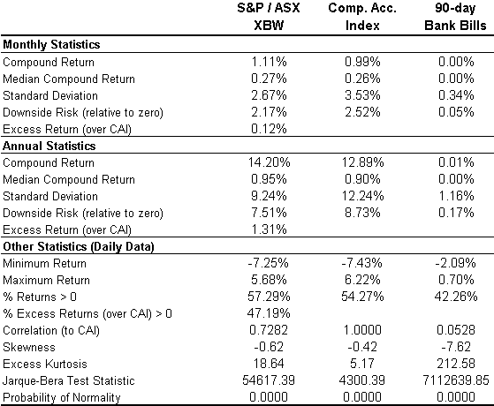
The compounded monthly return on the XBW was 1.11 per cent, 12 basis points higher than the S&P/ASX 200 Index. Risk, as measured by standard deviation was substantially lower, 2.67 per cent versus 3.53 per cent, which equates to 32 per cent reduction of risk per unit of return. The third section of this table provides some daily measures of performance that reveal the XBW’s investment characteristics further. For example, the buy-write index produced a higher percentage of positive returns compared to the S&P/ASX 200 Index and excess returns were achieved over 47 per cent of the time. Interestingly, the XBW has a lower correlation to the underlying stock index suggesting a further source of portfolio diversification.

Like the US market, the results reported in Table 3 also suggest that there is some negative skewness in returns (propensity for negative returns to occur greater than positive returns), which is in line with that reported by Whaley (2002). This is expected for the XBW in particular since a buy-write strategy truncates the upper end of the index distribution. Merton, Scholes and Gladstein (1978) found that, for a covered call strategy, skewness was initially negative but became slowly positive when deeper out-of-the-money call options were. From Table 2, the sample of call options chosen by Standard & Poor’s for the XBW during 2004/05 were, on average, 0.52 per cent out-of-the-money and assuming this trend is representative of the entire price series used in this study, negative skewness of 0.62 resulted. Conversely, El Hassan, Hall and Kobarg (2004) used call options that were between 5 and 15 per cent out-of-the-money and observed negative skewness of about 0.90. Therefore these results support the extant literature although it would be interesting to determine the rate of change between skewness and out-of-the-money call strikes.

The results reported in Table 3 are stronger than those reported in the US market by Whaley (2002). He finds that while the index-only and the buy-write portfolios generate similar returns, 1.187 per cent versus 1.106 per cent, over the period June 1988 to December 2001 (approximately 14 per cent per annum), the standard deviation of returns on the buy-write portfolio is smaller than the standard deviation of returns on the index portfolio. On an equivalent annual basis, the standard deviation of return on the index portfolio in the US was 14.21 per cent as compared to that of the buy-write portfolio that stood at 9.22 per cent (similar to the annual risk reported here for the Australian equivalent) evidently highlighting the buy-write strategy’s risk reducing properties.

Chart 4 shows the standardised daily returns of the XBW and the CAI in relation to the normal distribution. The buy-write and the composite accumulation indices are slightly negatively skewed but this would not be considered severe. What does stand out, however, is that both distributions have greater excess-kurtosis, particularly the XBW; 18.64 versus 5.17 for the CAI. The former index plainly exhibits higher overall returns compared to the latter but what is more striking is how compact the distribution is around its mean despite its fatter tail. In contrast, the CAI has a much greater dispersion around its mean demonstrating its riskier nature.

Chart 4: Distribution of Daily Rates of Return – 1991 to 2006
As expected, the Jarque-Bera statistic rejected the hypothesis that the three investments’ distribution of returns is normal, which confirms the need for stochastic dominance as a measure of relative performance. Whaley (2002) and others believe these observations are reassuring in the sense that the MV portfolio performance measures work well for symmetric distributions but not for their asymmetric equivalents.

Chart 5 below shows the performance of the XBW vis-à-vis the CAI over the period December 1991 through December 2006 and provides a comprehensive representation of the wealth-effects of investing $10,000 in the buy-write strategy relative to the index-only portfolio. From the outset, the XBW tracked the XJO closely but begins to pull away during 1995. By 2001, the XBW sprints upward in a rapid but volatile fashion underlying its ability to generate additional alpha in bearish or trendless markets.

Following the resumption of the equity bull market in 2003, the XBW begins to lead the XJO but at a much slower pace. This is expected since a passive buy-write strategy collects quarterly premium income but has a truncated upside when the option is exercised above the strike price. This means, at least theoretically, that the XBW should under-perform the market is a bull market.

Chart 5: Buy-write Strategy – Growth of $10,000 initial investment
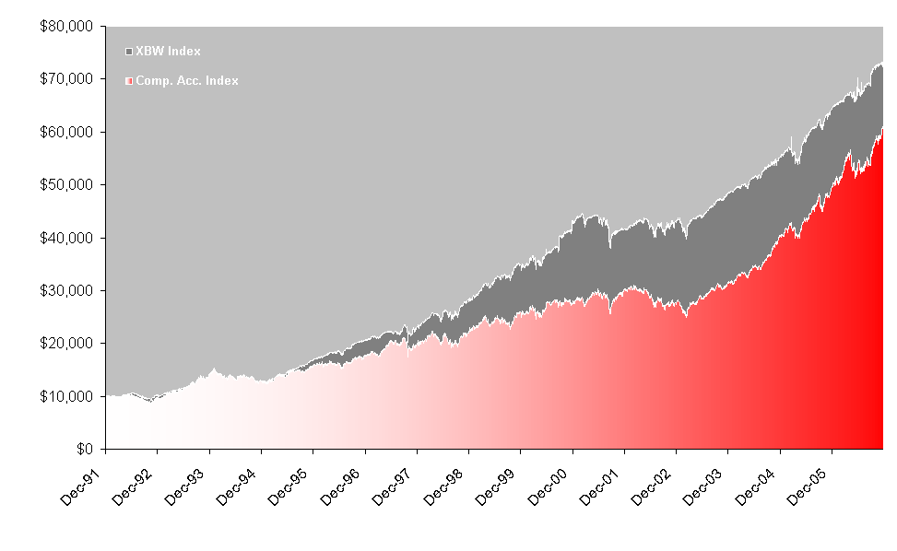
Chart 6 overleaf graphically depicts the annualised risk and returns characteristics for four popular financial investments in Australia over the period December 31, 1991 to December 29, 2006. The XBW averaged a 14.20 per cent annual return, 1.31 per cent higher than the CAI implying that one dollar compounding at this constant rate would have grown to $7.32 over the evaluation period. In addition, the XBW’s superior return was achieved for a standard deviation of 9.24 per cent, approximately 75 per cent of the 12.24 per cent of risk for the CAI.

Chart 6: Annualised Return vs. Risk (December 31, 1991 - December 31, 2006)

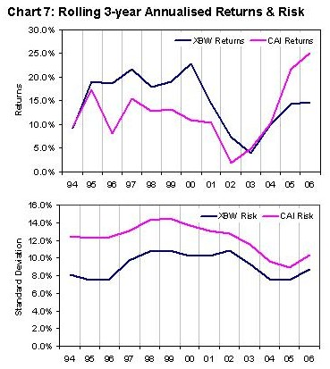Chart 7 below depicts the rolling 3-year annualised returns and risk since 31 December 1991. The XBW has essentially outperformed the CAI until the bull market of 2003 began upon which the underlying index has been the better performer. This of course underlines the buy-write strategy’s main defect in that it is unsuited, generally, to strong bull markets. What is interesting here is that the lead up to the technology bubble saw underlying rolling average returns on the benchmark index actually decline despite the euphoric optimism that continued to drive markets higher. This observation clearly shows the market in a distribution phase: “smart money” exiting the market replaced by uninformed investors who perpetuated the bubble.

In contrast, the XBW provided the better return potential over this period and its aftermath. Unlike the US market at this time, returns on the Australian equities remained positive during the resulting bear market and were actually just above the prevailing risk-free rate of return.

In terms of risk, the rolling 3-year annualised standard deviations; the XBW has exhibited consistently lower volatility compared to the underlying index.

5.2 Portfolio Performance Measures

Table 4 below evaluates the performance of the two index strategies using the measures outlined in Section 4.2 in both the standard deviation and semi-standard deviation framework. As with the Whaley (2002) study, the results here support two conclusions. The first is the confirmation that the risk-adjusted performance of the buy-write strategy is positive and significant, even when typical transaction costs are deducted. A comparison of Sharpe and M² ratios for the Accumulation Index and buy-write portfolio confirms that the risk-adjusted performance of the latter outperforms the risk-adjusted performance of the former on a mean-standard deviation basis and mean-semi standard deviation basis. The excess return ranges between 5.63 per cent and 6.81 per cent per annum on a risk-adjusted basis.

Table 5: Risk Adjusted Performance Measures
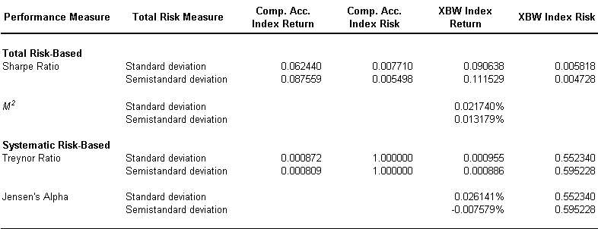
The second conclusion concerns measures based on semi-standard deviation that give weaker results than those measures using standard deviation to the extent that index returns are slightly negatively skewed. Due to the greater occurrences of negative returns, the two measures of risk should differ simply reflecting any skewness present. For example, from Jensen’s Alpha, the calculation of beta (through regression analysis) gives a value of 0.552 using mean-standard deviation and 0.595 when using mean-semistandard deviation, however the difference between the alpha coefficients suggests a skewness penalty exists of about 3 basis points per day.

This penalty can be interpreted as the cost of decreasing risk; whilst overall risk has decreased, the propensity for negative returns has increased. Given that investors are generally risk averse, they should be compensated for this by higher returns, which, in the mean-variance framework, can be shown as a decrease in the cost of returns. Calculating the variance (σ²) to return ratio for both the XBW and the CAI, shows that the average cost of returns for the former is almost 50% less than the latter (6.4108 v 12.3328), which of course confirms the findings of Morad and Naciri (1990).

5.3 Stochastic Dominance Tests

Using the FSD test, pair-wise comparisons of the two portfolios show that neither portfolio first-order stochastically dominates the other. However, the XBW is slightly stronger dominating 49 per cent of comparisons as opposed to 37 per cent for the CAI. This was confirmed by the KS test in EViews™ where the D-value of 0.3881 resulted in a p-value of zero.

The results of the SSD test show again that neither portfolio second-order stochastically dominates the other but the XBW is approximately nine-tenths stronger than CAI for all comparisons. As expected, the ambiguity of the FSD and SSD arose due to XBW and CAI curves intersecting on the CDF chart as per Appendix 3. Again the KS test generated a D-value of 0.7405 with a p-value of zero.

The TSD test, however, shows the greatest evidence of stochastic dominance, with the XBW dominating 100 per cent of comparisons indicating that the XBW will be preferred to the CAI by all non-satiated, risk averse investors with a preference for positive skewness. However, this was not confirmed by the KS test whose p-value was again zero.

Tests between the XBW and the risk-free money market investment show no dominance of any order. The CAI, however, dominates the risk-free money market investment on a second order stochastic basis, and by implication TSD indicating the index portfolio is preferred by non-satiated, risk averse investors. From an investors perspective these results show that conducting a FSD test is essentially useless. Both these KS tests resulted in p-values of unity.

5.4 Outlier Analysis

The statistical tests undertaken in this study firmly reject the hypothesis of normality present in any of the three return distributions but given the relatively symmetrical distribution patterns previously observed in both the XBW and CAI then it can be considered statistically appropriate to continue to use Grubb’s test for outliers as the impact of statistical error should be small.

Table 6: Results of Grubbs’ Test for Outliers
Index | G-stat (Maximum) | G-stat (Minimum) | Critical Value (5%)
XBW | 9.6721 | 12.3706 | 4.3510
CAI | 8.0049 | 9.5743 | 4.3510

As per the Table 5, the null hypothesis is rejected for the respective minimum and maximum values for the XBW and CAI at the 5% significance level respectively indicating that outliers do indeed exist within the two data sets.

Given that the extreme points of each return distribution are outliers, it is then necessary to determine the number of outliers within each data set and their effect upon the results. A visual examination of Chart 10 in Appendix 2, for example, shows the possible existence of a secondary, negative, linear relationship within the underlying data that may be exerting an unknown influence on the estimates of the Jensen’s Alpha regression coefficients.

Table 7: Extent of Outliers within each Dataset
Regression | Outliers | Percentage | Mean | St. Dev.
Standard Deviation | 44 / 3772 | 1.17% | -1.21559E-17 | 0.999867
Semi-standard Dev | 49 / 3772 | 1.30% | 2.64473E-16 | 0.999867

Investigation of the outliers reveals a number of interesting phenomena: many outliers reoccurred at periodic intervals particularly at the end of the calendar and financial years, around Easter and at each triennial federal election. In addition, following a review of the business headlines over the sample period, events such as Asian currency crisis, tech wreck, WTC terrorist attacks, the re-opening of the NYSE following WTC attacks, corporate scandals such as Enron, HIH, Ansett and One.Tel and the invasion of Iraq are all fairly well represented by the identified outliers.

Analysis of the regression output from the outlier-adjusted dataset shows the expected reduction in the standard errors and an enhancement in the R² thus improving the apparent fit of the model to the data. As can be seen in Table 7, there has been a marginal increase in each intercept meaning that had the events described above not occurred, then the investor would have earned a higher excess return. In addition, there has been a slight deterioration in the betas indicating that outliers are a source of volatility and their removal lessens the XBW’s sensitivity to the market. Overall the coefficient estimates appear stable when the outliers are removed and so their continued existence is unlikely to alter the conclusions presented in this paper.

Table 8: Summary of Regression Output for Outlier-adjusted Dataset
 | SD Regression |  | SSD Regression
Measure | w/ outliers | w/o outliers | w/ outliers | w/o outliers
Standard Error | 0.00400851 | 0.00302170 | 0.00243727 | 0.00167627
R² | 0.53007739 | 0.63396730 | 0.56742672 | 0.65123435
Intercept (α) | 0.00026141 | 0.00028473 | -7.57917E-05 | -9.74422E-05
Slope (β) | 0.55234007 | 0.54302017 | 0.59522830 | 0.54754366

The geo-political events described above contain useful information about market behaviour. These would have had an impact upon the results reported earlier, by periodically altering the risk / return relationship between the XBW and the CAI over the evaluation period. This being the case then, the coefficient estimates should not be static but would fluctuate frequently as the market reacted to external events.

The data is split into three equal sub-periods. Given that the majority of the “one-off” (as opposed to the cyclical) events captured by the outliers were focussed around the new millennium, the second sub-period should exhibit an increase in volatility as measured by changes in excess returns (alpha) and market sensitivity (beta) when compared with the remaining sub-samples.

Table 9: Sub-period Regression Models
Sub-period | Dates | Model | T | RSSsp
1 | 01/01/1992 to 31/12/1996 | r_{xbw} = 0.0004 + 0.4435r_{cai} | 1244 | 0.0151
2 | 01/01/1997 to 31/12/2001 | r_{xbw} = 0.0003 + 0.6532r_{cai} | 1263 | 0.0191
3 | 01/01/2002 to 31/12/2006 | r_{xbw} = 0.0002 + 0.5006r_{cai} | 1265 | 0.0237

Table 8 does indeed show the expected increase in beta during the second sub-period despite the fact that the alpha, being very small, has decreased. The test statistic for the Chow tests (26 & 27) are 66.13 and 25.01 respectively and when compared to a 5% significance level, the critical values from the F-distribution are 3.00 in both cases. The null hypotheses are firmly rejected implying changes to the coefficient structures in sub-periods 1 & 2 and 2 & 3 thus concluding that the alpha and beta estimates were not constant over the entire sample history. This means that the Jensen’s Alpha coefficient estimates are likely to be somewhat understated and any predictive forecasts based on this data should be viewed with suspicion.

5.5 The Source of Returns

Selling four index options per year produces significant income. Feldman and Roy (2005), and Callan and Associates (2006) demonstrated that implied volatility reflected in the price of S&P 500 options is often higher than realised volatility suggesting that calls trade at a premium to their fair value.

Chart 8: Index Call Option Daily Realised Volatility and Quarterly Premiums
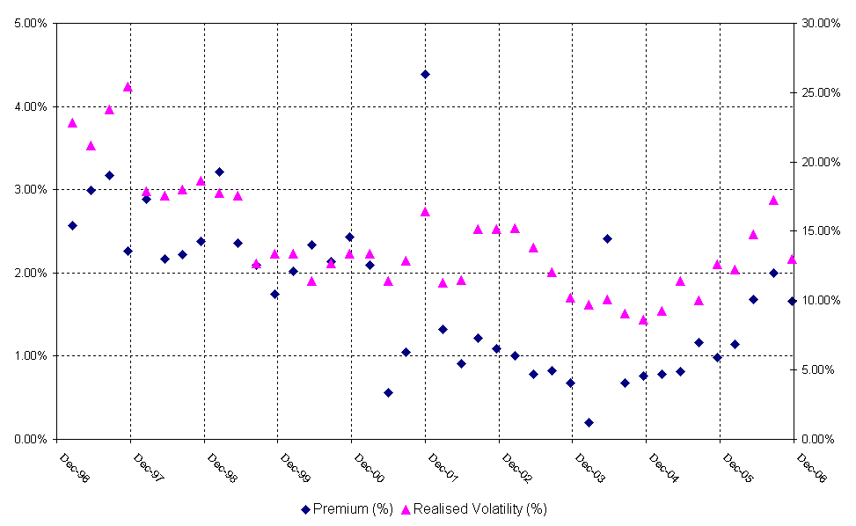
The Australian index call quarterly premiums earned as a percentage of the underlying value are plotted in Chart 8 above. Over the 60 quarters studied, the index options were found to have an average daily-realised volatility of 14.45 per cent with an average quarterly premium of 1.66 per cent of the underlying value, an annualised rate of 6.81 per cent.

Premium levels are closely tied to volatility expectations: as the Chart shows, premiums rose sharply in line with daily realised volatility in the bull markets of 1997 and 2003, and through the sharp market decline in between. Volatility was high during 1997 reflecting the fallout from the Asian economic crisis and again during the recession of 2000 – 2003. The intervening bull markets witnessed a decline in volatility.

Over the period analysed, index option volumes averaged 151 contracts per calendar quarter. There were, however, a minimum number of 10 and maximum number of 705 traded contracts illustrating an extreme range of activity and highlights the relatively low levels of liquidity in the Australian options market. This observation is in line with Groothaert and Thomas (2003, p. 10) who believe that any attempt to sell a sufficient quantity of index options would cause quoted premiums to fall sharply, which would impact upon the viability of the buy-write strategy and, as more often than not, leave the investor with a long only position.

5.5 Portfolio Diversification with an Index Buy-write Strategy

Callan and Associates (2006) showed that the buy-write characteristic of the BXM reduces correlation with both domestic and international equity markets, which therefore offers the potential for diversification.

The correlation between the XBW and CAI is approximately 0.73, as mentioned in Section 5.1, indicating that the addition of the XBW to a portfolio of blue chip equities would deliver further diversification benefits. This less than perfect correlation is due to the premium received from writing call options and the truncated upside return potential leading to an overall modified total return distribution.

Chart 9 below shows how the MV efficient frontier expands when the XBW is added to an investment portfolio consisting of a mix of cash / fixed interest and the top 200 Australian stocks. The addition of the XBW to such a portfolio would have generated significant improvement in the risk-adjusted performance over the past 15 years. It is interesting to note that since the XBW offers higher returns for a reduction in risk compared to the underlying index, as per Chart 6, any positively weighted combination of these two assets will not create an efficient portfolio. In fact, the only way to create an efficient frontier is to short sell the S&P/ASX 200 Index and invest the proceeds into the XBW.

Chart 9: The Mean-Variance Efficient Frontier

6. Summary and Conclusions

This study examines the performance of a buy-write strategy involving the purchase of the index portfolio and writing one just-out-of-the-month index call option for the Australian stock market. Specifically, the paper attempted to find out if the buy-write strategy can be used to compose a more efficient risk / return portfolio than would be the case with an index-only portfolio. The methodology used was that of Whaley (2002) in which three portfolios were constructed; one for bank accepted bills held to maturity, another consisting of the benchmark index-only strategy and the third for a benchmark index portfolio hedged by covered index call options.

The results here exceed those of Whaley (2002) in that the Australian buy-write strategy generates a higher return compared to the index-only portfolio, and the standard deviation of returns is significantly less than that on the index portfolio. On both a total risk, systematic risk-adjusted and third stochastic dominance basis the buy-write strategy outperforms the index portfolio. Consistent with Whaley (2002) for the US market, we conclude that a buy-write strategy appears to be a profitable wealth creation tool in the Australian market.

This study effectively asserts that the buy-write index strategy produces abnormal returns compared to the index only portfolio. If the underlying index were in fact a close proxy to the market model then this result would be seen to violate the EMH. This hypothesis asserts that since markets are efficient, investors are rational, and prices reflect all available information. Attempts by investors to obtain abnormal returns through either trading strategies or fundamental analysis will prove to be futile after including trading costs and adjusting for risks. Practitioners often find that empirical phenomena are difficult to reconcile within the framework of traditional finance theory. This study suggests that there is indeed “free money left on the table” during the time period from writing options over an investible index. This disconnect can be explained by evaluating the assumptions of traditional finance theory such as, the demand curves for stocks are kept flat by riskless arbitrage between perfect substitutes. In reality, individual stocks do not have perfect substitutes. As a result, arbitrageurs and computerised trading programs that instantaneously capture risk-free arbitrage opportunities face market frictions that inhibit the ability to exploit many inefficiencies, such as fund managers’ inelastic demand for index options for example.

The results in this paper support the case that traditional finance theory, i.e. EMH, does not adequately explain the idiosyncrasies of the real world. However, the identification of behaviour that violates efficient market assumptions may indeed indicate opportunities to exploit market inefficiencies and generate consistent abnormal returns with lower risk. The following framework identifies exactly how the assumptions of EMH are violated by fund managers’ inelastic demand for index options that frequently occurs when there is a clear need to boost returns on large, well-diversified stock portfolios, during periods of trendless market activity.

There are three main assumptions underpinning the EMH that are regularly violated in the real world: homogeneous expectations, investment markets are frictionless, i.e. there are no transaction costs, or restrictions on short-sales and that perfect competition exists, whereby market participants, regardless of their size, can transact without affecting prices. Dealing with each assumption in turn, it is a difficult proposition to expect all investors to share the same belief about the expected return and risk involved in a particular investment. For example, arbitrageurs and index managers rationale for trading is inconsistent and biased with Brock and Hommes (1998) illustrating diversity in agents’ beliefs, and Guilaume et al (1995) arguing that participants’ objectives and time horizons exhibit heterogeneity. Trading costs, short sale restrictions, and imperfect hedges are institutional frictions that all exist in the Australian financial market, which inhibit market participants (arbitrageurs) from exploiting inefficiencies since they wish to avoid unhedged risks. Similarly, in market reality, large investors impact asset prices in a far more material fashion than other investors (Darden Capital Management, 2006).

This study suggests that abnormal returns can be achieved by implementing a buy-write options trading strategy that boosts the returns available on a large, well-diversified stock portfolio. As mentioned earlier, the average monthly return from the buy-write portfolio was 1.11 per cent, which translated into a total annual return from the trading strategy of 14.20 per cent with the largest daily loss of (7.25 per cent). The average annual abnormal return was 1.31 per cent, which was accompanied by a visible reduction in the standard deviation of returns. The buy-write portfolio was profitable and exceeded the return on the index portfolio over 47 per cent of the time. As demonstrated by this example, in which violations of efficient market assumptions are identified and exploited (namely call option overpricing), the ability to recognize and understand violations of traditional finance theory and EMH can reveal unidentified market inefficiencies that can be captured with profit.

It should be pointed out that proponents of EMH believe that excess returns are caused by incorrect or inadequate “risk-adjusted” performance measurements. Lhabitant (1998) believes that MV performance measures give equal weight to either positive or negative returns through truncation of one side of the distribution hence the sequence of stochastic domination alluded to earlier. An important consequence, Lhabitant (1998), Groothaert and Thomas (2003) and others believe is that when the underlying asset for the options is the market portfolio (i.e. an index), the buy-write strategy will appear to beat the non-optioned portfolio, i.e. the market itself. Using options in a MV context (e.g. Sharpe ratio), “beating the market is easy”, which is in contradiction to EMH.

While this study shows the superiority of the Australian index buy-write/covered call strategy under the MV and stochastic dominance frameworks, it is limited by the relatively small and segmented local options market. Liquidity is scarce and market makers dominate, which leads to frequent mispricing that tends to deter large-scale participation by the wider investment community. In addition, whilst this study ignores transaction costs for simplicity, they are subject to a minimum floor before rising proportionately with the value traded. In general, Australian option premiums tend to be small so the investor needs to be trading a substantial number of contracts before the strategy becomes worthwhile after considering trading costs.

Further work is required in the Australian options market to determine the extent of index call and put mispricing and its effect upon the abnormal returns generated from a simple index buy-write strategy. Whether the evident mispricing is due to competition among portfolio managers for insurance or the lack of liquidity remains unclear. To this author’s knowledge there is no extant study to date that clearly addresses these issues and this might be a fruitful area of future research.
References
Adams, J. and Montesi, C 1995, Major Issues related to Hedge Accounting, Norwalk.

Australian Stock Exchange 2004, The S&P/ASX Buy Write Index (XBW), [Brochure], ASX.

Australian Stock Exchange 2006, Buy-write Strategy Fact sheet, [Brochure], ASX.

Balzer, L, A 1994, ‘Measuring Investment Risk: A Review’, The Journal of Investing, 3, Fall.

Belsey, D, A, Kuh, E and Welsch, R, E 2004, Regression Diagnostics: Identifying Influential Data and Sources of Collinearity, Wiley, New York.

Benesh, G, A and Compton, W 2000, ‘Historical Return Distributions for Calls, Puts and Covered Calls’, Journal of Financial and Strategic Decisions, Spring 2000, pp. 35 – 42.

Bollen, N, P, B and Whaley, R, E 2004, ‘Does Net Buying Pressure Affect the Shape of Implied Volatility Functions?’ Journal of Finance, Vol. LIX, No. 2, April, pp. 711 – 753.

Bookstaber, R and Clarke, R, G 1979, ‘An algorithm to calculate the return distribution of portfolios with option positions’, Management Science, Vol. 25, No. 7, pp. 609 – 622.

Bookstaber, R and Clarke, R, G 1984, ‘Option portfolio strategies: Measurement and evaluation’, Journal of Business, Vol. 57, pp. 469 – 92.

Bookstaber, R and Clarke, R, G 1985, ‘Problems in evaluating the performance of portfolios with options’, Financial Analysis Journal, Jan – Feb, pp. 435 – 450.

Bondarenko, O 2003, Why are Put Options So Expensive? Retrieved January 8, 2007, from www.hss.caltech.edu/~pbs/copenhagen/readings/Bondarenko-puts.pdf

Booth, J, R, Tehranian, A and Trennepohl, G, L 1985, ‘Efficiency analysis and option portfolio selection’, Journal of Financial and Quantitative Analysis, pp. 435 – 450.

Brace, A and Hodgson, A 2001, ‘Index Futures Options in Australia – An Empirical Focus on Volatility’, Accounting and Finance, 31, pp. 13-30.

Brock, W, A and Hommes, C, H 1998, ‘Heterogeneous Beliefs and Routes to Chaos in a Simple Asset Pricing Model’, Journal of Economic Dynamics and Control, 22, pp. 1235 – 1274.

Brooks, C 2004, Introductory Econometrics for Finance, Cambridge, London.

Brooks, R, Levy, H and Yoder, J 1987, ‘Using stochastic dominance to evaluate the performance of portfolios with options’, Financial Analysts Journal, March – April, pp. 79 – 92.

Callan and Associates 2006, An Historical Evaluation of the CBOE S&P 500 Buy Write Index Strategy, [Brochure], Callan.

Chicago Board Options Exchange 2002, The CBOE BuyWrite Monthly Index (BXM), [Brochure], CBOE.

Chiras, D, P and Manaster, S 1978, ‘The Information Content of Option Prices and a Test of Market Efficiency’, Journal of Financial Economics 6, no. 2/3, pp. 213 – 234.

Clarke, R, G 1987, ‘Stochastic dominance properties of option strategies’, Advances in Futures and Options Research, Vol. 2, pp. 1 – 18.

Czerwonko, M and Perrakis, S 2006, Transaction Costs and Stochastic Dominance Efficiency in the Index Futures Options Market. Retrieved January 21, 2007, from http://ssrn.com/abstract=891254

Darden Capital Management 2006, The Darden Capital Management Advisor: February/March 2006. Retrieved October 22, 2006, from
http://student.darden.virginia.edu/dcm/pdf/Advisor/DCM%20Advisor%20Mar06.pdf

El-Hassan, N., Hall, T. and Kobarg, J., 2004, ‘Risk and Return of Covered Call Strategies for Balanced Funds: Australian Evidence’, Research Project, University of Technology Sydney. Retrieved December 18, 2006, from http://www.asx.com.au/investor/pdf/covered_calls_report_final.pdf

Feldman, B and Roy, D 2004, ‘Passive options-based investment strategies: The case of the CBOE S&P 500 Buy Write Index’, Research Project, Ibbotson and Associates. Retrieved September 28, 2006, from http://www.ibbotson.com/

Fortune, P 1996, ‘Anomalies in option pricings: the Black-Scholes model revisited’, New England Economic Review, March / April.

Galai, D 1978, ‘Empirical Tests of Boundary Conditions for CBOE Options’, Journal of Financial Economics 6, no. 2/3, pp. 187 – 211.

Groothaert, T and Thomas, S 2003, ‘Creation of a Eurex Buy-Write Monthly Index on SMI’, Masters Thesis, University of Lausanne. Retrieved December 18, 2006, from
http://www.hec.unil.ch/cms_mbf/master_thesis/0315.pdf

Guillaume, D. M, Dacorogna, M, M, Dave, R, D, Muller, U, A, Olsen, R, B and Pictet, O, V 1995, ‘From the Bird’s Eye to the Microscope: A Survey of New Stylized facts of the Intra-Daily Foreign Exchange Markets’, mimeo, Fordham University. Retrieved October 21, 2006, from http://www.bnet.fordham.edu/Academics/Colleges__Graduate_S/Graduate__Profession/GBA/index.html

Harlow, W, V 1991, ‘Asset Allocation in a Downside Risk Framework’, Financial Analysts Journal, September – October.

Hill, J and Gregory, K 2003, Covered Call Strategies on S&P 500 Index Funds: Potential Alpha and Properties of Risk-Adjusted Returns. Retrieved January 9, 2007, from http://207.36.165.114/Denver/Papers/Covered_Call_Strategies_FMA.pdf

Isakov, D and Morard, B 2001, ‘Improving portfolio performance with option strategies: Evidence from Switzerland’, European Financial Management, Vol. 16, No. 1, pp. 73 – 90.

Jarnecic, E, 2004, ‘Return and Risk of Buy-Write Strategies using Index Options: Australian Evidence’ Research Project, SIRCA. Retrieved September 21, 2006, from
http://www.sirca.org.au/research/index.html

Johnson, L, J 1986, ‘Foreign-Currency Options, Ex Ante Exchange-Rate Volatility, And Market Efficiency: An Empirical Test’, Financial Review 21 (4), pp. 433-450.

Kahneman, D and Tversky, A 1979, ‘Prospect Theory: An Analysis of Decision Making under Risk’, Econometrica, 47, pp. 263 – 291.

Leggio, B and Lien, D 2000, Is Covered Call Investing Wise? Evaluating the Strategy Using Risk-Adjusted Performance Measures. Retrieved January 21, 2007, from http://207.36.165.114/Denver/Papers/IsCoveredCall.pdf

Leggio, B and Lien, D 2002, ‘Covered Call Investing in a Loss Aversion Framework’, The Journal of Psychology and Financial Markets, Vol. 3, No. 3, pp. 182-191.

Lhabitant, F. S 2000, ‘Derivatives in Portfolio Management: Why Beating the Market is Easy’, Derivatives Quarterly, Winter, pp. 39 – 45.

Markowitz, H. M 1952, ‘Portfolio Selection’, The Journal of Finance, March, pp. 77 – 91.

Markowitz, H. M 1959, Portfolio Selection: Efficient Diversification of Investments. John Wiley & Sons, New York.

Merton, R C 1973, ‘Theory of Rational Option Pricing’. Bell Journal of Economics and Management Science, 4 (1), pp. 141 - 183.

Merton, R, C, Scholes, M, S and Gladstein, M, L 1978, ‘The return and risks of alternative call option strategies’, Journal of Business, Vol. 51, no. 2, pp. 183 – 242.

Merton, R, C, Scholes, M, S and Gladstein, M, L 1982, ‘The return and risks of alternative put option strategies’, Journal of Business, Vol. 55, no. 1, pp. 1-43.

Meyer, T, O, Li, X and Rose, L 2005, ‘Comparing mean variance tests with stochastic dominance tests when assessing international portfolio diversification benefits’, Financial Services Review, Summer.

Morard, B and Naciri, A 1990, ‘Options and investment strategies’, Journal of Futures Markets, Vol. 10, pp. 505 – 517.

O’Grady. B and Wozniak, G 2002, ‘The performance of the covered call strategy in a portfolio context’, Honours Thesis, Curtin University of Technology. Retrieved August 12, 2006, from Curtin University of Technology Digital Theses.

Ordean, T 1998, ‘Are investors reluctant to realise their losses?’, Journal of Finance, 53, pp. 1775 – 1798.

Radoll, R, W 2001, ‘Hedging Covered Calls: A Way to Profit while Minimizing Risk’, Futures, November.

Rebonato, R 2004, Volatility and Correlation: The Perfect Hedger and The Fox, John Wiley and Sons, New York, pp. 3 – 30.

Rendleman, R, J 1999, ‘Option Investing from a Risk-Return Perspective’, Journal of Portfolio Management, May, pp. 109 – 121. Retrieved January 29, 2007 from ABI/INFORM Global.

Standard and Poor’s 2006, S&P/ASX200: The Institutional Benchmark for the Australian Market, [Brochure], S&P.

Steiner, A 2006, Stochastic Dominance. Retrieved January 21, 2007 from http://www.andreassteiner.net/performanceanalysis/index.php?External_Analysis:Other_External_Measures:Stochastic_Dominance

Tergesen, A 2001, ‘Taking Cover with Covered Calls’, Business Week, May 21.

Thaler, R, Tversky, A, Kahneman, D and Schwartz, A 1997, ‘The effect of myopia and loss aversion on risk taking: an experimental test’, Quarterly Journal of Economics, 112, pp. 647 – 661.

Whaley, R, E 2002, ‘Return and Risk of CBOE Buy Write Monthly Index’, Journal of Derivatives, Winter, pp. 35-42.

Appendix 1 – Option Contract Specifications used in the XBW

Table 10: S&P/ASX 200 Index Options
Underlying asset | S&P/ASX200 Accumulation Index
Exercise style | European
Settlement | Cash settled based on the opening prices of the stocks in the underlying index on the morning of the last trading date.
Expiry day | The third Thursday of the month, unless otherwise specified by ASX.
Last trading day | Trading will cease at 12 pm AEST on expiry Thursday. This means trading will continue after the settlement price has been determined.
Premium | Expressed in points
Strike price | Expressed in points
Index multiplier | A specified number of dollars per point e.g. AUD $10
Contract value | The exercise price of the option multiplied by the index multiplier
Source: ASX website

Table 11: SFE SPI Options (on Index Futures)
Contract Unit | Valued at A$25 per index point
Contract Months | Options expire in the same calendar month as the underlying SPI futures contract.
Commodity Code | AP
Listing Date | March 1983 to March 2000
Minimum Price Movement | 0.5 index points (A$12.50)
Exercise Prices / Style | Set at intervals of 25 index points/American
Last Trading Day | Trading ceases at 12 pm AEST on the last day of trading of the underlying futures contract.
Settlement Price | The Cash Settlement Price of the underlying futures contract.
Trading Hours | 5.10 pm – 8.00 am and 9.50 am – 4.30 pm AEST.
Settlement Day | ITM options automatically exercises. Upon exercise the holder receives the underlying SPI contract at the exercise price.
Source: SFE website

Appendix 2 – Regression Analysis

2.1 Regression analysis based on standard deviation

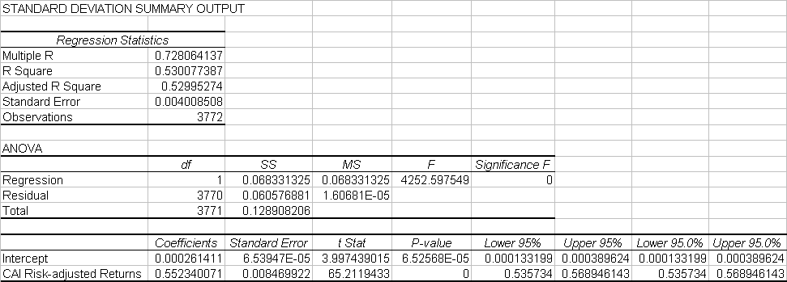
Table 12: Jensen’s Alpha Regression based on Standard Deviation

2.2 Regression analysis based on semi-standard deviation

Table 13: Jensen’s Alpha Regression based on Semi-standard Deviation
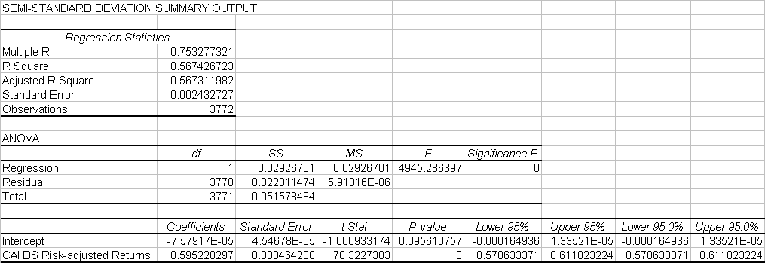

2.3 Regression analysis based on standard deviation without outliers

Table 14: Jensen’s Alpha Regression based on Standard Deviation without Outliers
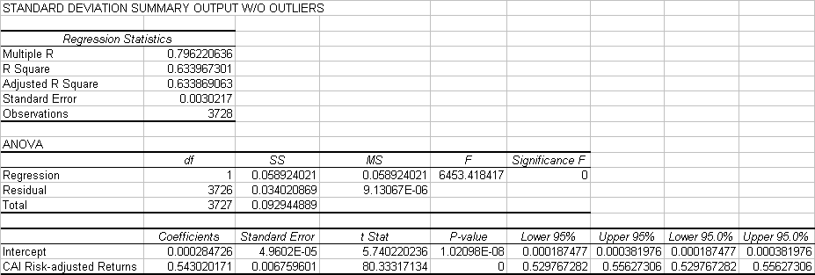
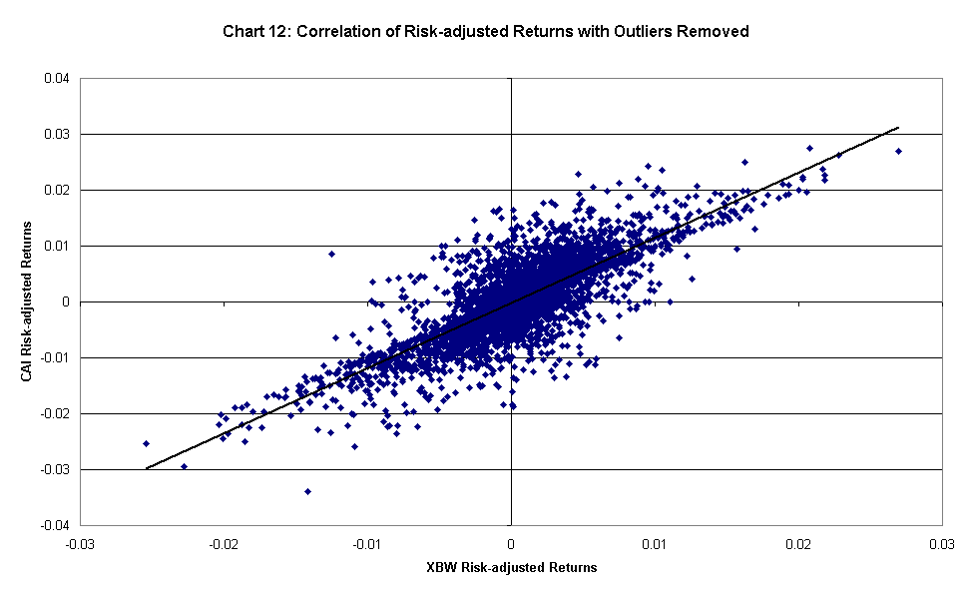

2.4 Regression analysis based on semi-standard deviation without outliers
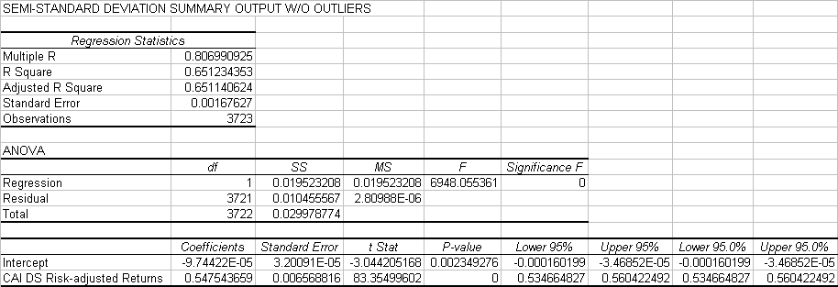
Table 15: Jensen’s Alpha Regression based on Semi-standard Deviation without Outliers

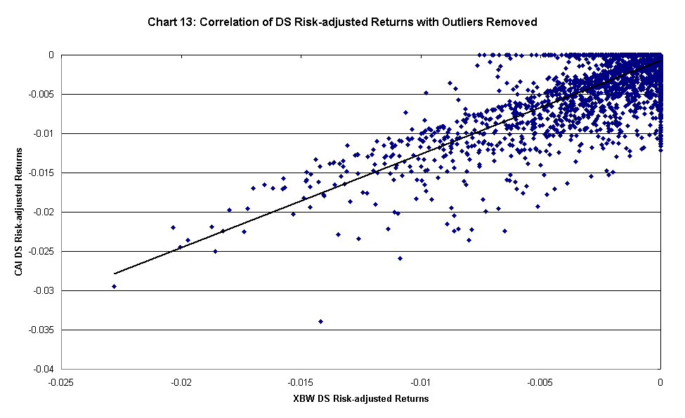

Appendix 3 – Transaction Costs

3.1 Introduction

Green and Figlewski (cited in Leggio and Lien, 2002) believe that the buy-write strategy is only profitable if the call option is significantly overpriced. Therefore, it is only a viable strategy for investors who can recognise and take advantage of mispriced options. This may be feasible for institutions that can rebalance portfolios at the lowest transaction cost but Leggio and Lien (2002) insist that the buy-write strategy is unlikely to be a profitable for individual investors.

This author conducted a survey of Australian online brokers to ascertain typical charges in relation to establishing a $1M portfolio of domestic equities that resembled an index buy-write strategy. The average cost of establishing a portfolio valued at $1M of stocks mimicking the index would have been $5,550 and the cost of writing four options per year amounted to $160. Therefore the maximum brokerage cost would have been 0.5715% of the portfolio’s value in the first year and 0.016% thereafter.

3.2 Assumptions and Calculations

The calculations undertaken represent the impact that a typical level of transaction costs would have upon the index buy-write strategy. In order to make this analysis as close to reality as possible, a number of assumptions were required to underpin the calculations:

- A S&P/ASX 200 portfolio was constructed using GICS weightings (see Table 2) as published by S&P;
- The GICS weightings applied to initial portfolio value of $1m;
- The number of stocks within a given GICS category are divided into each weighting values to give an average transaction value (ATV);
- Online brokers provide the cheapest charges to an individual investor wishing to trade in Australian equities. As will be seen from Table 1 (overleaf), of the 18 brokers sampled, only 6 provided an options trading service;
- The average brokerage rates, for equities and options (when offered) computed by sampling 18 online brokers, was then applied to the ATV to give a proportionate amount of brokerage payable to establish the required constituent position within the portfolio;
- The total brokerage payable thus represents the most likely cost to establish an index portfolio;
- Changes in the weightings / constituents will incur additional brokerage rates as rebalancing is required, but the nature of future changes is unknown today and so are ignored;
- The ongoing difference in costs between the two strategies represents the costs of writing four call options per year.

Table 16: Sample of Typical Fees for Australian Internet Brokers
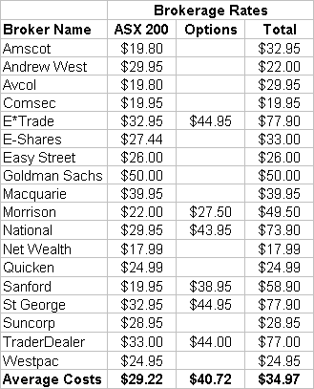

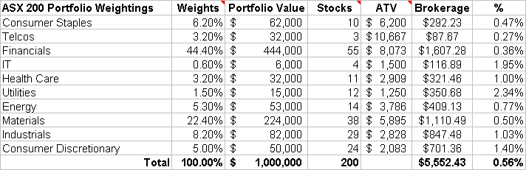
Table 17: Portfolio Construction and Associated Charges

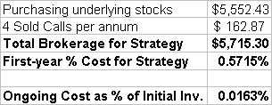
Table 18: Summary of Transaction Costs

3.3 Conclusion

So net of transaction costs, the index buy-write strategy is highly profitable both on a standalone and on an excess return (to the market) basis.

Appendix 4 – Stochastic Dominance

Chart 14: Return Distributions
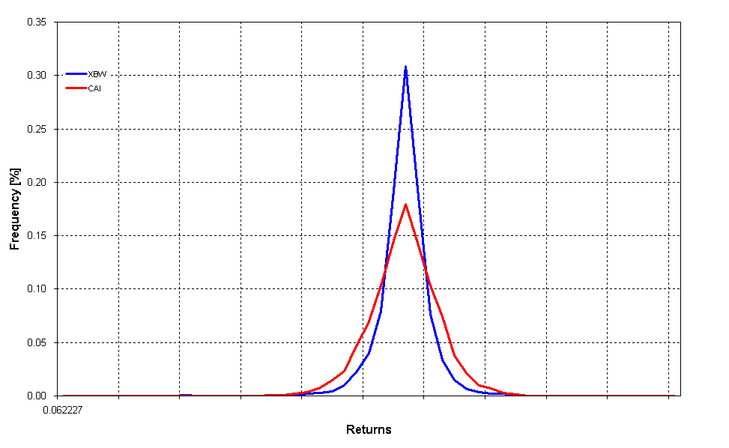
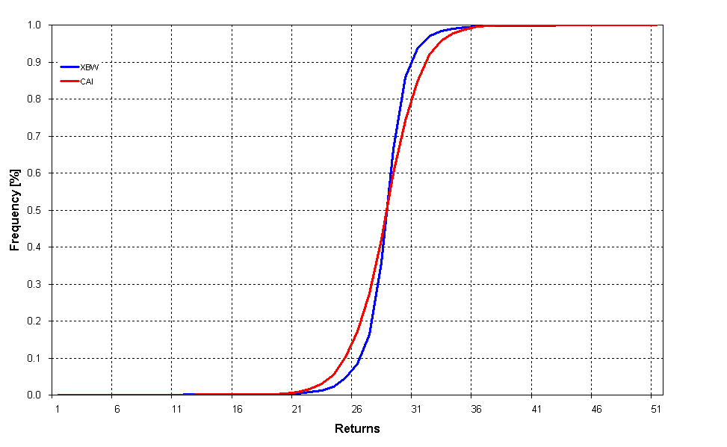
Chart 15: First Stochastic Dominance

Chart 16: Second Stochastic Dominance
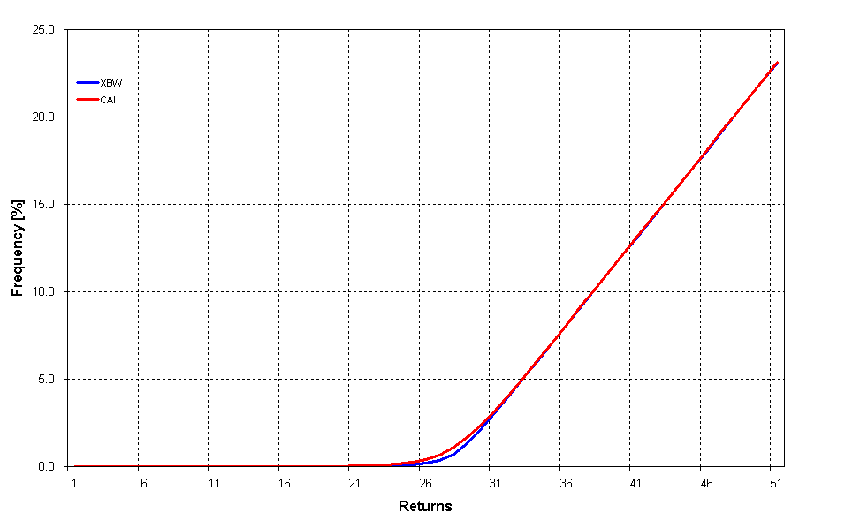
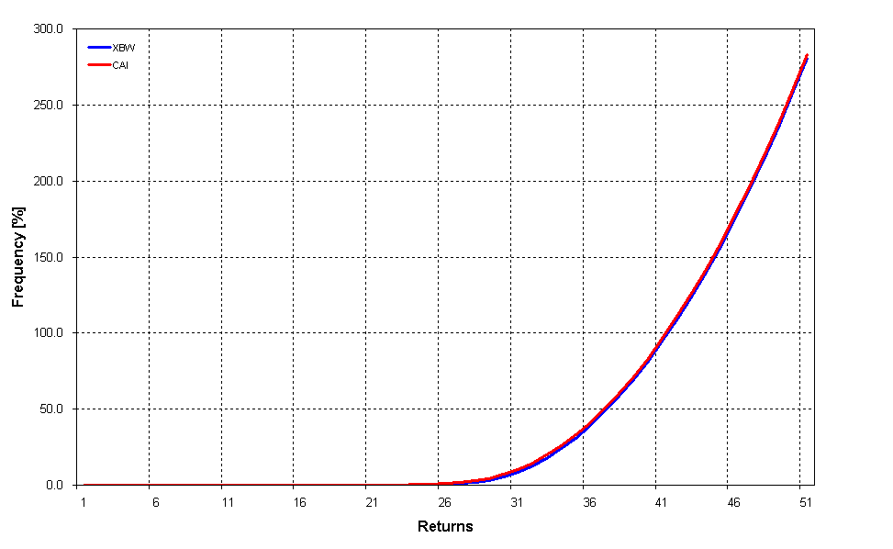
Chart 17: Third Stochastic Dominance

Appendix 5 – Efficient Portfolios

Investing in different asset classes and in the securities of many issuers is a method widely employed to reduce overall investment risk. It also avoids damaging a portfolio's performance by the adverse performance of a single security, industry or country investment. The addition of less than perfectly correlated assets reduces unsystematic risk and therefore the variability of the return until finally only market risk, which is undiversifiable, remains. An efficient portfolio is a combination of securities that for a given level of risk, there is no portfolio with a higher expected return and for a given expected return, there is no portfolio with a lower level of risk.

By applying Modern Portfolio Theory, an efficient frontier of two risky assets, namely the ASX 200 Index and the XBW Index, can be constructed. Firstly the correlation and covariance measures were obtained to allow for the construction of the optimal-risky and the minimum-variance portfolios. As was noted earlier, the optimal risk portfolio of these two assets requires the ASX 200 Index to be shorted and to become overweight in the XBW; this is due to the fact that for a less risk the former delivers higher returns seemingly contrary to EMH.
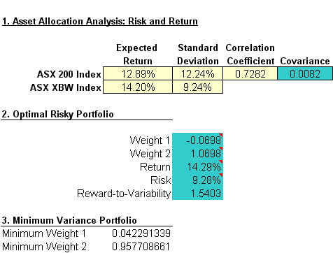

The next step was to construct a table of different weight combinations and calculate the portfolio’s mean, standard deviation and reward to variability ratio (see Table 1 overleaf). The first two measures are then plotted to derive the efficient frontier as per Chart 1. All combinations of portfolios where the weight of the XBW component is less than approximately 1.07 do give the highest return for the minimum risk (confirmed by the reward to variability ratio) and all portfolios below the mean-variance line are inefficient.
Table 19: Calculation of the Mean–Variance Efficient Frontier

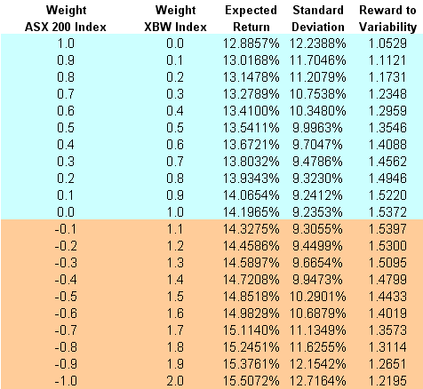

Chart 18: The Mean–Variance Efficient Frontier

A buy-write strategy is commonly, although inaccurately, known as a covered call strategy. See Section 3.1 for further details.
Option strategies have become very popular with retail investors over the past few years boosted by extensive financial press coverage (O’Grady and Wozniak, 2002). For example, a search of the Australian Financial Review website yielded a total of nine articles relating to the buy-write strategy in 2006 alone. Option strategies are regularly featured in both Your Trading Edge and AFR Smart Investor magazines.
While the implied volatility refers to the market's assessment of future volatility, the realized volatility measures what actually happened in the past.
See for example Brace and Hodgson, (1991).
The Sharpe ratio, developed by William Sharpe was originally called the “reward-to-variability” ratio before being referred to as the Sharpe Ratio by academics and financial professionals. This ratio measures risk-adjusted performance of an investment asset or trading strategy. The Treynor Ratio, developed by Jack Treynor, is similar, except that it uses Beta as the volatility measurement. Return is defined as the incremental average return of an investment over the risk free rate. Risk is defined as the Beta of the investment returns relative to a benchmark. See Section 4.2 for algebraic definitions or each ratio.
The Sortino Ratio, so named after its creator Frank A Sortino, is simply a modification of the Sharpe ratio in which semi-standard deviation is used. While the Sharpe ratio takes into account any volatility in return of an asset, Sortino ratio differentiates volatility due to up and down movements. The up movements are considered desirable and not accounted in the volatility.
The upside potential ratio is a measure of a return of an investment asset relative to the minimal acceptable return. The measurement allows investors to choose strategies with growth that is as stable as possible for a given minimum return.
This capitalization-weighted index tracks the performance of 500 widely held large-cap stocks in the industrial, transportation, utility, and financial sectors.
Whaley assumes that the dividend is paid overnight.
This finding also has implications for EMH.
The Stutzer Index is a performance measure that rewards portfolios with a lower probability of underperforming a benchmark. It differs from the Sharpe ratio since it does not assume that returns are normally distributed, rather it takes into account the shape of the distribution of returns. Where the distribution is normal, the Stutzer index and Sharpe ratio are identical.
Jarnecic’s (2004) methodology is detailed fully in Section 4.1.1.
It is interesting to note that in 2006 a number of Australian investment houses such as Macquarie Investments and Aurora have followed their US counterparts and begun introducing retail investment funds solely focussed on generating returns based on a passive index buy-write strategy.
In financial mathematics, the implied volatility of a financial instrument is the volatility implied by the market price of a derivative security based on a theoretical pricing model.
The put call parity relationship is as follows: S + P = C + E / (1+r)^{-t} where S is the spot price, P is the put price, C is the price of an equivalent (in terms of time to maturity and exercise price) call, E is the exercise price of the call, r is the risk free rate and t is the time to maturity of the option. Arbitrage implies that if the combination of put and stock price is worth more than the call plus the present value of bonds, then one would sell short puts and stock and buy the call and bonds thus placing upward pressure on the price of the calls (Jarnecic, 2004).
The Peso Problem refers to a situation when a rare but influential event could have reasonably happened but did not happen in the sample. The phenomenon was first observed in the Mexican Peso market in the early 1970s. Refer Friedman (1976) for further details.
Refer Fortune (1996).
Such a disconnect can be the result of an agency relationship, for example, which gives rise to pricing discrepancies between the observed prices and those predicted by the EMH even if (and, actually especially when) all the players are fully rational (Rebonato, 2002).
Mid-2006 witnessed the merger of the SFE Corporation Limited (SFE) and Australian Stock Exchange Limited (ASX) to form a new entity known as the Australian Securities Exchange, which is now one of the world’s top 10 listed exchange groups, measured by its market capitalisation.
The Australian Stock Exchange listed options on the All Ordinaries Index from 8 November 1999 to April 2000 after which they were no longer listed.
See O’Grady and Wozniak (2002) on the popularity of this option strategy in Australia.
Unlike the options examined in Whaley (2002), the proceeds from writing Australian options are not available at the time of sale.
Futures options on the All Ordinaries Index were first listed on the SFE on June 1985 with calendar quarter expiries. All SFE index options expire on the third Thursday of the expiration month and settlement price is the closing value of the stock index. Commencing with the December 2001 contract, the settlement price was an index value based on the first traded price of the component stocks of the index on the expiration day.
The Australian government ceased issuing short-term treasury notes in June 2002 and the overnight cash rate is not investable making Bank Accepted Bills the only proxy for the risk free rate.
It is interesting to note that the two methods used differ only in their measurement objectives; the ASX / Jarnecic version measures return but to convert this to an index level requires the former to be multiplied by the previous period’s index level, as per S&P.
Jensen's alpha (or Jensen's Performance Index) is used to determine the excess return of a stock, other security, or portfolio over the security's required rate of return as determined by the CAPM. It takes the form of an OLS regression function.
The M² ratio is a return adjusted for volatility that is measured in basis points and allows for a comparison of returns between portfolios. It is considered easier to interpret than the Sharpe Ratio.
Jensen’s Inequality relates the value of a convex function of an integral to the integral of the convex function.
See Massey (1951)
S&P rebalance the ASX 200 index on a quarterly basis to reflect changes in both liquidity and constituent composition. The recalculated index is simply appended to the previous day’s calculation so as to maintain the price series and is disseminated to the ASX and all data vendors accordingly.
See Appendix 3 for a discussion on actual transactions costs associated with a retail client undertaking such a strategy. The average cost of establishing a portfolio valued at $1M of stocks mimicking the index would have been $5,550 and the cost of writing four options per year amounted to $160. Therefore the maximum brokerage cost would have been 0.5715% of the portfolio’s value in the first year and 0.016% thereafter. So net of transaction costs, the index buy-write strategy is highly profitable both on a standalone and on an excess return (to the market) basis.
Whilst the returns on a bank bill investment over the time horizon was negligible, the average interest rate on cash deposits was approximately 5% and this was used as a proxy for a fixed interest investment.
See Appendix 5 for further details.
It is the author’s experience that discount and full-service brokers’ fees for option trading are significantly higher than the samples given in Table 1 by as much as 100%. Coupled with a relatively low level of liquidity in the Australian options market, it would be unlikely that an individual investor using traditional brokerages would obtain the same buy-write results presented in this work.
GICS portfolio weightings current as at March 31, 2006.

